**Evaluating the role(s) of the Butte sink and Sutter Bypass for Butte Creek spring-run Chinook Salmon and other Central Valley juvenile salmonid populations - 2020 study year**

January 2021

**Prepared by:**

Flora Cordoleani a,b, Eric Holmes c, Miranda Bell-Tilcock c, Carson Jeffresc , Rachel Johnson b,c

a Institute of Marine Sciences, Fisheries Collaborative Program, University of California Santa Cruz Santa Cruz, 1156 High Street, Santa Cruz 95064, USA

b National Oceanic and Atmospheric Administration, National Marine Fisheries Service, Southwest Fisheries Science Center, 110 McAllister Way, Santa Cruz 95060, USA

c University of California Davis, Center for Watershed Sciences, One Shields Ave, Davis 95616, USA

**Prepared for:**

James Earley, US Fish and Wildlife Service & CVPIA

Agreement Number: F19AC00062



**TABLE OF CONTENTS**

LIST OF TABLES 3

LIST OF FIGURES 3

DISCLAIMER 5

SUMMARY 6

INTRODUCTION 7

OBJECTIVES 8

MATERIALS AND METHODS 9

Site locations 9

Hydrology 12

Water quality sampling 12

Zooplankton sampling 13

Caged salmon experiment 15

Salmon diet 17

Growth estimation and modelling 17

Wild fish sampling 18

RESULTS 18

Hydrology 18

Water quality 22

Zooplankton 26

Caged and wild salmon diet 28

Caged salmon growth 31

Wild fish capture 37

DISCUSSION 41

ACKNOWLEDGEMENTS 45

REFERENCES 46

# LIST OF TABLES

Table 1. Cage site locations across the different regions, and associated data collection. 9

Table 2. Number of salmon lethally sampled at each sampling date and for each site location. Numbers in parentheses denotes “placebo” fish stocked in weeks 2 or 4, to keep the same number of fish per cage over the course of the experiment. Asterisk denotes fish stocked in week 1 at Feather River to replenish 2 cages (1 growth and 1 gut content) which were beached during the descending hydrograph. 16

Table 3. A. Anova test results showing the significance level of region and habitat type factors on the mean daily growth rate. 33

Table 4. Comparison of FL growth rate mixed effect models, with habitat type used as a random variable. Npar= number of model parameters; AICc = Akaike’s information criterion corrected for small sample size; ΔAICc = difference in AICc score between the given model and the most parsimonious model. Models are ordered from lowest to highest AICc. Lower AICc scores indicate greater relative model parsimony. 36

Table 5. Number (N) of wild caught run specific salmon, with their minimum, mean, and maximum fork length (FL). 39

# LIST OF FIGURES

Figure 1. Study area map with the different regions considered and the fish cage locations. The Butte Creek watershed is separated in three regions: 1) Butte Sink: North of Colusa weir, 2) Upper Bypass: Colusa weir to Tisdale weir, 3) Lower Bypass: Tisdale weir south to Sacramento River. 11

Figure 2. Top panel: hydrograph of the Sacramento River at Butte City (BTC), Feather River at Boyd’s Landing above Star Bend (FSB), and Butte Creek flow at Durham (BCD) stations. Bottom panel: historical Tisdale Weir overtopping during December to May of each year 2000 to 2019. The vertical black lines in the top panel show the cage experiment time window. 19

Figure 3. A. Stage-inundation rating curve, the line shows the linear model in Equation 2. B. Stage duration curve, showing the probability of exceeding a given stage. 20

Figure 4. Map of the amount of inundated areas (blue) along the Sutter Bypass, for varying stages (53.71 ft, 52.82 ft, 47.77 ft, 46.73 ft, 43.81 ft and 41.52 ft) measured at BSL. 21

Figure 5. Dissolved oxygen (DO, in mg/L) and water temperature (°C) time series at the various cage locations. 22

Figure 6. Physical water quality parameter time series at the various cage locations. 24

Figure 7. Nutrient loading time series at the various cage locations. 25

Figure 8. Total zooplankton density (per m³), from ambient zooplankton sampling, summed for all taxa displayed on a log scale with trend lines for the different regions. The symbols represent zooplankton density for the different habitat types. The black vertical lines show the cage experiment time period. 27

Figure 9. Mean weekly lower trophic species density by region and functional taxonomic group. The black vertical lines show the cage experiment time period. 28

Figure 10. Percent composition of caged salmon gut stomach contents taken at week 2, 4 and 6, in one selected site per region (i.e. BSW2 in Butte Sink, FRC1 in Feather River, LBW1 in Lower Sutter Bypass, SRC2 in Sacramento River, and UBW1 in Upper Sutter Bypass). 29

Figure 11. Percent composition of caged salmon gut stomach contents (top panel) and lower trophic sample (lower panel) taken the day prior to cage removal. 30

Figure 12. Mean percent composition of wild fall-run sized salmon stomach contents (N = 71) grouped by sampled region. The “Butte Sink Wetland” region includes Mallard Ranch and Sanborn Slough sampling sites, the “Sacramento River Weirs” region is comprised of Tisdale and Colusa weirs sampling sites, and the “Lower Sutter Bypass” region corresponds to Lundberg Farms sampling site (see Figure 18). 31

Figure 13. Average daily growth rates in mm/day and g /day at each site location. Error bars denote standard error. 32

Figure 14. Mean daily fish growth rates (mm/day) boxplot grouped by region and habitat type. 34

Figure 15. Pairwise comparison of mean daily growth rates (mm/day). A. for each habitat type. B. for each region. If a segment crosses the 0 vertical line, it means that the difference between growth rates is not statistically significant. 35

Figure 16. Relationships between caged fish mean daily growth rate (mm/day) and log zooplankton density (per m³). A. for all locations combined, and B. by habitat type. The dots represent the raw data, the black line shows a simple linear regression, and the colored lines show habitat specific daily growth rate predictions from the best mixed effects model. 37

Figure 17. Fish species caught during the wild trapping events performed from January to April in the Butte Sink and Sutter Bypass. Black-colored names correspond to native species while red-colored names correspond to non-native species. 38

Figure 18. Study area map with pie charts showing the proportion of winter-, fall-, late fall-, and spring-run Chinook Salmon sampled at different locations along the Butte Sink and Sutter Bypass. Run assignment is based on Length-At-Date criteria. 40

Figure 19. Chinook Salmon size histogram categorized by month from January to April, and by run type. Run assignment is based on Length-At-Date criteria. 41

Figure 20. Satellite imagery showing lateral banding from April 13, 2019 in the lower Sutter Bypass. Image was downloaded from Planet.com. 44

# DISCLAIMER

# This information provided in this document is preliminary or provisional and is subject to revision. It is being provided to meet the need for timely best science. The information has not received final approval by the National Oceanic and Atmospheric Administration (NOAA) and is provided on the condition that neither NOAA nor the U.S. Government shall be held liable for any damages resulting from the authorized or unauthorized use of the information.

# 

# SUMMARY

California’s Central Valley (CCV) Chinook Salmon stock has declined substantially since the mid-1800s with the spring, winter and late-fall runs listed as threatened or endangered, and the fall run heavily supplemented by hatcheries. As the largest population of CCV wild spring-run Chinook, Butte Creek fish are an important source for promoting life history diversity in the CCV Chinook Salmon community. This ESA listed population has been a relatively successful and stable population compared to other threatened Central Valley spring-run Chinook Salmon populations (i.e. Mill, Deer and Battle Creek). The Butte Sink and Sutter Bypass have been suggested to play an important role in their success by providing juvenile salmon a rich floodplain rearing habitat before their out-migration to the Pacific Ocean.

This project had several purposes. The first one was to quantify the differences in growth between the Butte Sink, Sutter Bypass, and adjacent Sacramento and Feather River habitats, for Butte Creek juvenile Chinook Salmon and other CCV Chinook Salmon populations that could potentially access those habitats. The second goal was to better understand the complex hydrology of the lower Butte Creek watershed during baseline and flooding conditions, and to characterize the food web composition and its dynamics through time. The third goal was to identify which runs of Chinook Salmon were accessing the Butte Sink and Sutter Bypass, when the weirs overtopped and Sacramento River water mixed with Butte Creek water.

2020 was the second year this project was implemented. In comparison to 2019, 2020 was a hydrologically dry year, with a lack of substantial precipitation in the winter leading to zero inundation of the Sutter Bypass from the Sacramento River via the passive weirs (i.e., Moulton, Colusa and Tisdale weirs). The key findings were that ….

Dry conditions excluded all salmon spawned in the Sacramento River and upstream tributaries (i.e., Mill Creek, Battle Creek, Deer Creek) from accessing the Butte Sink and Sutter Bypass. Spring-run and fall-run Chinook Salmon spawning in Butte Creek were presumably the only fish with access to Bypass channels and wetlands, and were captured during seining events.

# 

# INTRODUCTION

The California Central Valley (CCV) supports four runs of Chinook Salmon that are named according to the season in which the adults return to freshwater: fall-, late-fall-, winter-, and spring-run. Prior to Euro-American settlement, an estimated 1-2 million wild Chinook Salmon would return to the CCV rivers each year (Yoshiyama et al. 1998), achieving this abundance in large part because they had access to vast and diverse natural freshwater habitats, from which this unique diversity of Chinook Salmon life history strategies emerged.

Central Valley rivers once carried runoff from large winter storms and spring snowmelt onto low-lying floodplains, slowing and spreading water into complex mosaics of riparian forest and wetlands. Large flood basins, floodplains, and tidal wetlands were often inundated for long periods in most years providing food rich rearing habitat that was essential to support the large salmon populations. Those highly productive floodplain waters provided ideal conditions for juvenile salmon to feed and grow before migrating to the ocean (Welcomme 1979, Ribiero et al. 2004). Over the last century and a half, however, floodplain habitats have been diminished by 95% since pre-settlement levels (Hanak et al. 2011). Valued for their rich soils, most of the Central Valley’s floodplains have been converted to agriculture and have been disconnected from their rivers by levees and dykes (Speir et al. 2015). Flow alteration, especially the reduction of large flow events, from large upstream dams and water diversions, has also limited the inundation duration and extent of remnant floodplain habitats. The loss of floodplain habitat, along with other limiting factors such as the loss of spawning habitat and the degradation of remaining migratory corridors have taken a toll on CCV Chinook Salmon. Currently the fall- and late fall-run are listed as “Species of Concern”, fall-run is also heavily supplemented by hatcheries, spring-run is listed as threatened, and winter-run is listed as endangered under the Endangered Species Act (Williams 2006).

In order to control high flows that would otherwise inundate farmland and cities, the Sacramento Flood Control Project was created in 1911 and adopted by Congress in the Flood Control Act of 1917 (Kelley 1989). The Project was designed to passively spill water from the Sacramento River and tributaries through a system of weirs into a series of flood bypasses. The system of bypasses was designed to divert floodwaters from the main river channels and eventually convey the floodwaters into the Sacramento-San Joaquin Delta. The Sutter Basin is the uppermost flood bypass in the Sacramento Valley, encompassing approximately 14,000 hectares from the Butte Sink in the north to the confluence of the Sutter Bypass with the Feather and Sacramento Rivers near Verona in the south. In late winter and spring, Sacramento River water can flow into the Butte Sink and the Sutter Bypass via Moulton, Colusa, and/or Tisdale weirs. In addition, the upper Butte Creek watershed connects to the Butte Sink just north of the Sutter Buttes. The low lying topography of the Butte Sink and Sutter Bypass and the design of the weir infrastructure connected to the Sacramento River means that the Sutter Bypass floods nearly every year and is a crucial piece of the Central Valley Project relieving pressure on the levees of the Sacramento and Feather Rivers (CVFMPP 2010). The frequent inundation allows for off-channel ecosystem processes to persist in the current altered hydrologic landscape. These processes provide ecosystem services such as groundwater recharge, food web production, and off-channel habitat for aquatic species (Sommer et al. 2001, Grozholtz and Gallo 2006, Opperman et al. 2009).

Butte Sink and Sutter Bypass provide important rearing habitat for Butte Creek spring-run Chinook Salmon population, especially in years of extensive winter and spring flooding (Ward and Mc Reynolds 2004, Johnson and Lindley 2016). This ESA listed population has been a relatively successful and stable population compared to other threatened spring-run Chinook Salmon populations (i.e. Mill, Deer and Battle Creek; Azat et al. 2017). Recapture data of coded wire tagged (CWT) Butte Creek fry suggest that large numbers of spring-run juveniles reside for extended periods in the Butte Sink and Sutter Bypass before continuing their migration to the ocean (Ward and McReynolds 2004).

This project presents a unique opportunity to investigate the potential ecosystem benefits of one of the last ephemeral floodplain habitats found in the Sacramento Valley for the remaining populations of Chinook Salmon from the Sacramento River and its tributaries. This project focused on measuring the water quality, food web, and resulting performance of juvenile Chinook Salmon in the Sutter Basin and adjacent locations in the Sacramento and Feather Rivers. These findings will help inform water managers and habitat restoration and reconciliation efforts for Chinook Salmon in CCV.

# 

# OBJECTIVES

The purpose of this study was to quantify, for the second year in a row, the benefits of the Butte Sink and Sutter Bypass for juvenile Chinook Salmon compared to adjacent river channel habitats. We aimed at answering the following questions:

1. How does the hydrology of the Butte Sink and the Sutter Bypass (see Figure 1 for region’s delineation) affect juvenile Chinook Salmon?
2. What are the growth benefits to juvenile Chinook Salmon rearing in Butte Sink and Sutter Bypass in comparison to adjacent channelized rivers habitats?
3. What runs of Chinook Salmon utilize the Butte Sink and Sutter Bypass?

# MATERIALS AND METHODS

## Site locations

15 locations were selected for the 2020 study across the 5 regions of interest: 1) Butte Sink: North of Colusa weir, 2) Upper Bypass: Colusa weir to Tisdale weir, 3) Lower Bypass: Tisdale weir south to Sacramento River, 4) Sacramento River, and 5) Feather River (Table 1, Figure 1). Two different habitat types were identified; channel and off-channel wetland. Due to lack of flooding in 2020, no off-channel agriculture habitat was available. River channel and wetland sites from 2019 were replicated in 2020, with the exception of SRC1 which was moved downstream approximately 1km. Canal channel sites were added in anticipation of flooding which did not occur during the water year. They were opportunistically left in the canals as a comparison of productivity.

Table 1. Cage site locations across the different regions, and associated data collection.

|  |  |  |  |  |  |  |  |
| --- | --- | --- | --- | --- | --- | --- | --- |
| **Region** | **Location** | **Habitat type** | **Growth Cage Number** | **Gut Content Cage** | **Dissolved oxygen** | **Water quality** | **Lower trophic** |
| **Butte Sink** | BSW1 | Wetland | 3 | 1 | YES | YES | YES |
| BSW2 | Wetland | 3 | 1 | YES | YES | YES |
| BSC1 | Canal Channel* | 2 | 1 | YES | YES | YES |
| **Upper Bypass** | UBC1 | Canal channel | 2 | 1 | YES | YES | YES |
| UBC2 | Canal channel | 2 | 1 | YES | YES | YES |
| UBW1 | Wetland | 3 | 1 | YES | YES | YES |
| UBC3 | Canal channel | 1 | 0 | YES | YES | YES |
| **Lower Bypass** | LBW1 | Wetland | 3 | 1 | YES | YES | YES |
| LBC1 | Canal channel | 1 | 0 | Partial | YES | YES |
| LBC2 | Canal channel | 4 | 1 | YES | YES | YES |
| **Sacramento River** | SRC1 | River channel | 2 | 1 | YES | YES | YES |
| SRC2 | River channel | 2 | 1 | YES | YES | YES |
| SRC3 | River channel | 2 | 1 | YES | YES | YES |
| SRC4 | River channel | 2 | 1 | YES | YES | YES |
| **Feather River** | FRC1 | River channel | 2 | 1 | YES | YES | YES |

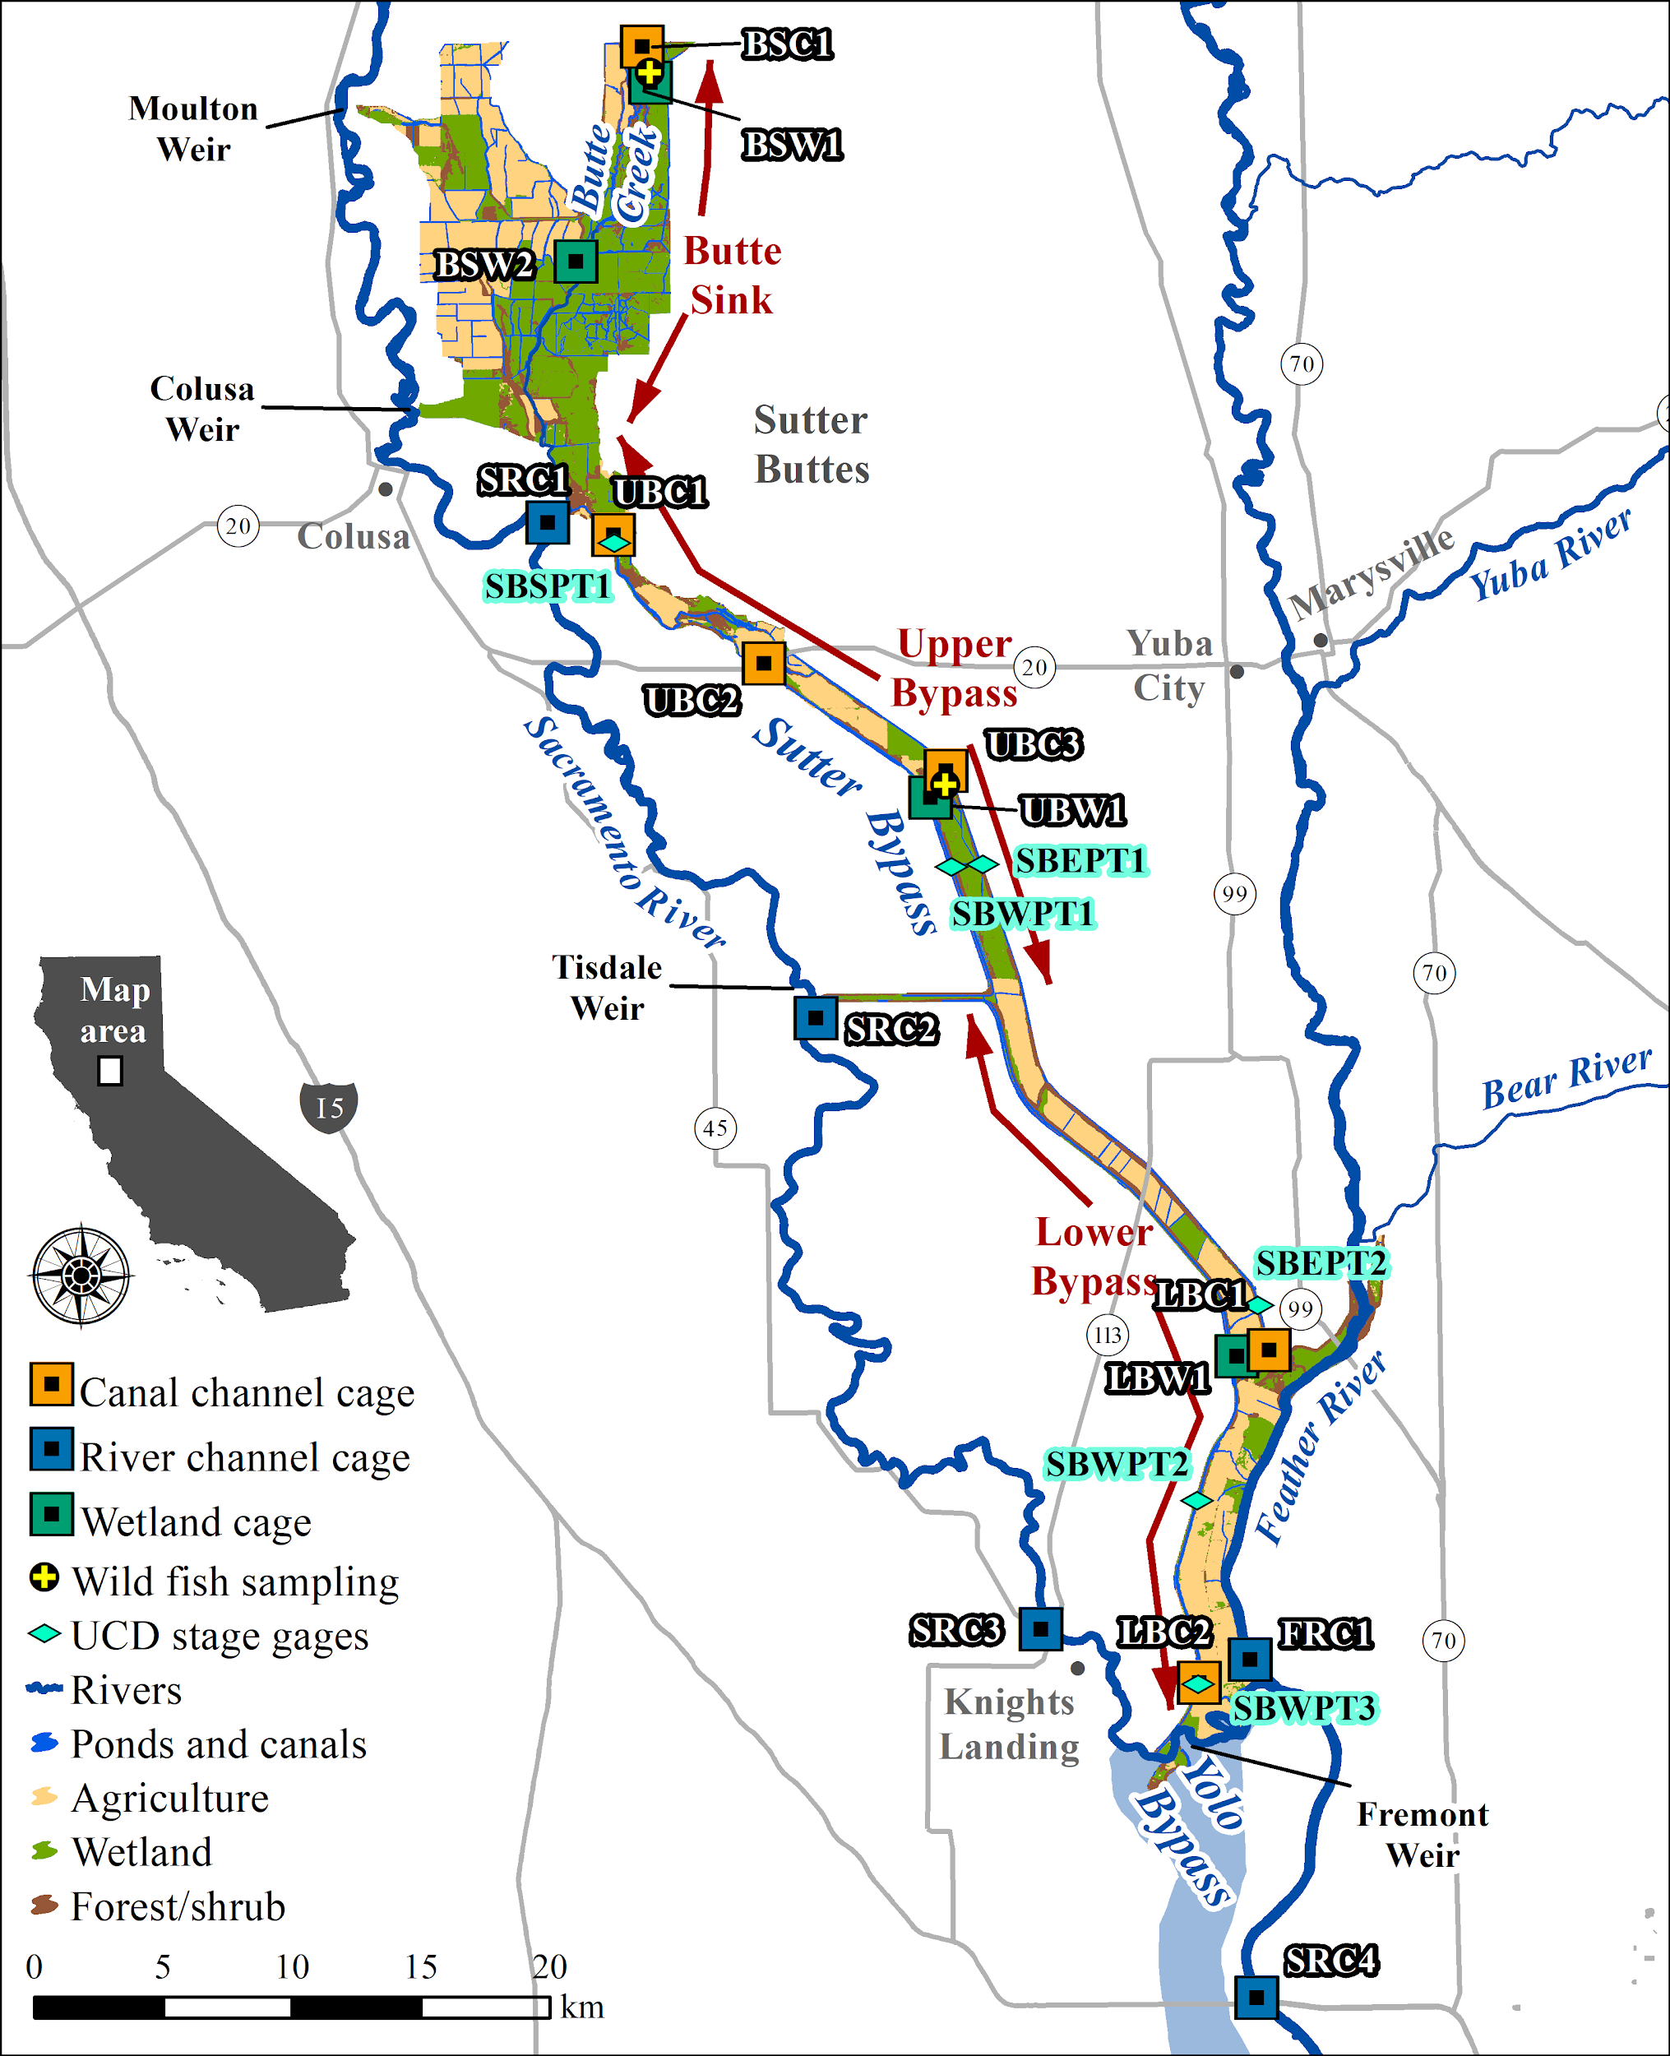

Figure 1. Study area map with the different regions considered and the fish cage locations. The Butte Creek watershed is separated in three regions: 1) Butte Sink: North of Colusa weir, 2) Upper Bypass: Colusa weir to Tisdale weir, 3) Lower Bypass: Tisdale weir south to Sacramento River.

## Hydrology

River flow data for the three main inputs; Sacramento River, Feather River, and Butte Creek, including the Butte Sink and Sutter Bypass was downloaded from the California Data Exchange Center (CDEC, <http://cdec.water.ca.gov/>). Sacramento River flow data came from the Sacramento River at Butte City (BTC) gaging station. Feather River flow came from the Feather River at Boyd’s Landing above Star Bend (FSB) station. Butte Creek flow data was obtained from the Butte Creek at Durham (BCD) station. Input to the Sutter Bypass from the Sacramento River at the three passive weirs was obtained from Sacramento River at Moulton Weir (MLW), Sacramento River at Colusa Weir (CLW), and Sacramento River at Tisdale Weir (TIS). Sutter Bypass flow was obtained from the Butte Slough near Meridian (BSL) gage.

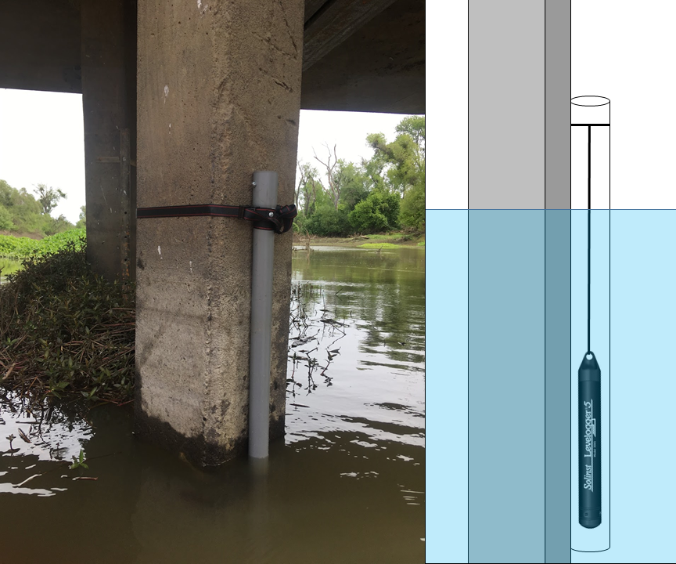

An array of six pressure transducers (Solinst Leveloggers, see picture above) was deployed in the Sutter Bypass channels to monitor stage fluctuations along the bypass (see Figure 1 for spatial distribution of the array). The transducers were installed in vertical stilling wells on the downstream side of bridge pilings in the borrow channels. Water surface elevation was surveyed using RTK GPS in the NAVD88 vertical datum and allowed conversion of logged stage to real world elevation. Discharge measurements surveyed with a Sontek M9 Acoustic Doppler Current Profiler (ADCP) in the spring of 2019 were used for rating curve development.

For the historical context of conditions observed in water year 2020, we used a flood classification method modified from Whipple et al. (2017) to identify historical flooding patterns and recurrence intervals in the Sacramento River. Daily flow data from Sacramento River at Bend bridge (USGS gage: 11377100) for the period 1893 to 2020 was used to identify individual flood events where mean daily discharge exceeded 20,000 cfs for a period of two or more days. The flood events were classified using unsupervised K-means cluster analysis (*kmeans* function from “stats” R package version 4.0.3., R Development Core Team 2015) based on explanatory variables including centroid day (centday), maximum flow (maxflow), duration in days (duration), and recession rate (fallrate). A principal components analysis biplot was used to visualize and interpret the contribution of explanatory variables to the flood clusters. Identified flood clusters were included in a flood recurrence interval calculation using Equation 1:

$Recurrence interval = (n + 1)/m$

*where: n = number of years on record Eq. 1*

*m = number of occurrences*

## Water quality sampling

Water quality sampling was performed at all cage locations from 1/13/2020 to 3/14/2020. Continuous water temperature (°C) and dissolved oxygen (mg/L, DO) were collected at all cage locations using submersible Onset U26 loggers continuously recording at a 15 minute interval and suspended approximately 0.5 meters below the water surface.

Point water quality data was also collected weekly at all locations with a YSI Exo2 multi parameter sonde. The parameters collected were: temperature (°C), dissolved oxygen percent saturation (%), dissolved oxygen concentration (mg/L), turbidity (NTU), chlorophyll-a concentration (ug/L), blue-green algae concentration (ug/L), electrical conductivity (ug/cm), salinity (PSU), and pH. Due to sonde malfunction and overlapping project use on a few occasions, water quality measurements were not taken in some weeks.

Additionally, water grab samples with 125mL bottles were used for laboratory water chemistry analysis. The parameters analyzed included total nitrogen (ppm), ammonium (NH4; ppm) , nitrate (NO3; ppm), total phosphorus (TP; ppm), phosphate (PO4; ppm), and dissolved organic carbon (DOC; ppm). Chlorophyll-a (ppb) and pheophytin α (ppb) was sampled with water grab samples in 1L bottles, filtered and analyzed at UC Davis. Due to COVID19, the lab responsible for processing water samples was closed and our samples from the majority of the project expired and were disposed of. However, we were able to measure EC from the samples, before disposal, with the use of a handheld conductivity probe.

## Zooplankton sampling and community analysis

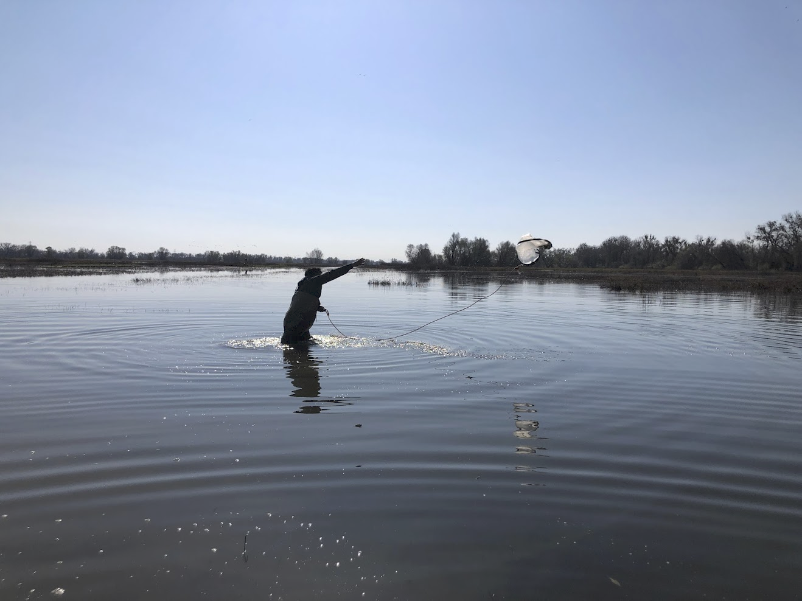

Zooplankton was sampled weekly, at all cage locations, from 1/13/2020 to 3/18/2020, using a 30 cm diameter 150 µm mesh zooplankton net thrown five meters and retrieved through the water column four times from the stream bank. To account for differences in sampled volume due to variable water velocities, a flow meter attached to the zooplankton net was used to estimate the volume of water sampled. All samples were preserved in a solution of 95% ethanol, and zooplankton species identification is currently ongoing at UC Davis lab. Zooplankton densities were estimated for all cage locations.

Zooplankton subsampling was necessary due to the high density of invertebrates within the samples. Samples were rinsed through a 150 µm mesh and then emptied into a beaker. The beaker was filled to a known volume to dilute the sample, depending on the density of individuals within the sample, and then sub-sampled with a 1mL large bore pipette. If densities were still too great for enumeration the sample was split using a Folsom splitter or a colander before sub-sampling with the bore pipette. The dilution volume, number of splits, and number of aliquots removed was recorded and used to obtain total estimates of invertebrates which were divided by the total volume sampled to estimate density. Zooplankton samples were sorted into two groups of one hundred. One group was for the taxonomic group with the highest amount of individuals counted. A second group was for the total individual counts of each of the other taxonomic groups added up such that they met or exceeded a hundred in their total numerical count. If a hundred counts of the single highest taxonomic group was reached, but not a hundred of the remaining total individuals, then in the following aliquots the highest taxonomic group was not counted. Invertebrates were identified with the aid of a dissecting microscope at 4x magnification to the lowest taxonomic level possible using keys from “Ecology and Classification of North American Freshwater Invertebrates” (Thorp and Covich 2009), “Recent Freshwater Ostracods of the World” (Karanovic 2012), and “An Introduction to the Aquatic Insects of North America” (Merritt et al. 1996). Copepods were only identified to family. Terrestrial invertebrates were rare and not included in final counts.

Ambient zooplankton taxa were grouped into operational taxonomic units (OTUs) for plotting and analysis components (Table 2). A zooplankton community analysis was performed on the OTUs using a non-metric multidimensional scaling (NMDS) approach (using the *vegan* package in R). We used bi-weekly OTU’s total densities (organisms m-3), to correspond with the growth measurement periods. Bi-weekly densities were standardized using a Hellinger transformation prior to analysis (Legendre and Gallagher 2000).

Table 2. Operational taxonomic units (OTUs) defined for ambient and gut zooplankton taxa.

|  |  |  |  |  |
| --- | --- | --- | --- | --- |
| ID | Zooplankton OTU | Gut OTU |  | Comment |
| 1 | Cladocera large bodied adult | Cladocera | #8e7cc3 |  |
| 2 | Cladocera large bodied larvae | #b4a7d6 |  |
| 3 | Cladocera small bodied adult | #d9d2e9 |  |
| 4 | Copepoda adult | Copepoda | #6fa8dc |  |
| 5 | Copepoda copepedite | #9fc5e8 |  |
| 6 | Ostracoda adult | Ostracoda | #6aa84f |  |
| 7 | Rotifera adult | Rotifera | #ffd966 |  |
| 8 | Insecta aquatic adult | Insect | #e69138 |  |
| 9 | Insecta aquatic larvae | #f6b26b |  |
| 10 | Insecta terrestrial adult | #f9cb9c |  |
| 11 | Insecta terrestrial larvae | #fce5cd |  |
| 12 | N/A | Amphipoda | #e06666 | Rare in ambient zooplankton samples due to inefficiency of method |

## Caged salmon experiment

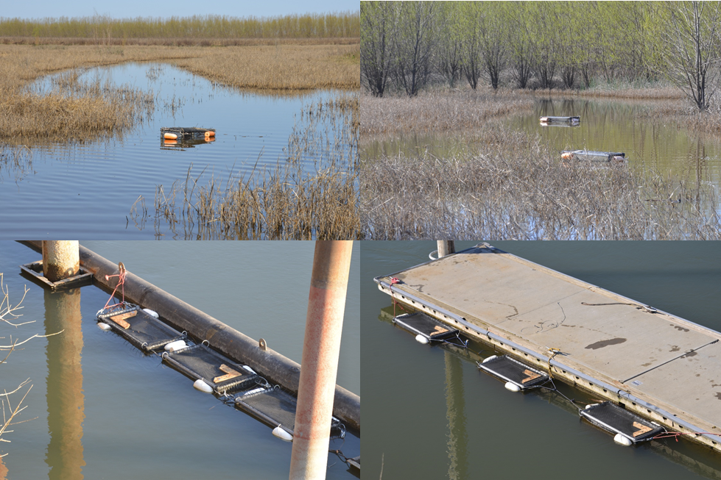

The cage experiment was implemented from 2/10/2020 to 3/18/2020 (i.e. 33 to 35 days per cage location) to study site-specific juvenile Chinook Salmon growth rates in the winter months. A high flow contingency plan resulted in additional cages installed in the Sutter Bypass borrow channel (LBC2 site) which would have allowed for deployment at three transects across the flooded bypass to test for lateral habitat differences under full bypass inundation conditions. Due to low flow and lack of inundation of adjacent agricultural fields, the extra cages at LBC2 remained in the channel (see Table 1 for site specific cage deployment numbers). Cages were utilized to maintain fish within a specific habitat for the duration of the study. Floating cage dimensions were 2’x2’x4’ and constructed with 1” pvc pipe frames enclosed with 1⁄4” plastic mesh material. The cages allowed for remeasurement of fish at a specific location as well as allowing for food resources to enter the cage that are of a suitable size for juvenile salmon.

Each cage was stocked with 5 individually PIT tagged juvenile fall-run Chinook Salmon sourced from the Coleman National Fish Hatchery. The caged salmon were measured for fork length (FL) to the nearest millimeter and weighed to the nearest 1/100th of a gram (g) with an Ohaus Scout Pro scale, at a two week interval except for the last week of the experiment (i.e. week 0: 2/10/2020-2/13/2020, week 2: 2/24/2020-2/26/2020, week 4: 3/9/2020 - 3/10/2020, and week 5 (end): 3/14/2020 - 3/18/2020). All locations except two channel sites UBC3 and LBC1 had an additional cage with 10 untagged fish to be sampled at a 2 week interval for gut content analysis. Three fish from each gut cage were randomly sampled and euthanized at weeks 2 and 4 (Table 3). Additionally, at the end of the experiment, all remaining caged fish were euthanized and were used for stomach contents identification.

Table 3. Number of salmon lethally sampled at each sampling date and for each site location.

|  |  |  |  |  |  |
| --- | --- | --- | --- | --- | --- |
| **Region** | **Location** | **Week 2**  **(2/24 - 2/26)** | **Week 4**  **(3/9 - 3/10)** | **Week 5**  **(3/14 - 3/18)** | **Total** |
| **Butte Sink** | BSW1 | 3 | 3 | 16 | 22 |
| BSW2 | 3 | 3 | 16 | 22 |
| BSC1 | 3 | 3 | 14 | 20 |
| **Upper Bypass** | UBC1 | 3 | 3 | 11 | 17 |
| UBC2 | 3 | 3 | 10 | 16 |
| UBW1 | 3 | 3 | 8 | 14 |
| UBC3 | 0 | 0 | 5 | 5 |
| **Lower Bypass** | LBW1 | 2 | 2 | 15 | 19 |
| LBC1 | 0 | 0 | 5 | 5 |
| LBC2 | 3 | 3 | 22 | 28 |
| **Sacramento River** | SRC1 | 2 | 2 | 10 | 14 |
| SRC2 | 3 | 3 | 11 | 17 |
| SRC3 | 3 | 3 | 11 | 17 |
| SRC4 | 3 | 3 | 12 | 18 |
| **Feather River** | FRC1 | 3 | 3 | 13 | 19 |

## Wild fish sampling

Due to a lack of substantial precipitation there were no recorded weir overtopping events to transport water from the Sacramento River this winter. Therefore water flowing through the Butte Sink and Sutter Bypass came entirely from the Butte Creek watershed. Although fish from the Sacramento River could not access the Butte Sink and Sutter Bypass, wild fish sampling, using fykes and beach seines, was performed approximately bi-weekly from 2/4/20 to 3/14/20 to characterize Butte Creek spring- and fall-run juvenile access to managed wetland areas in the Butte Sink and at the Wildlife Refuge in the Sutter Bypass. Chinook salmon were measured for fork length to the nearest millimeter, weighed to the nearest 0.01 g, and fin clips were taken. A subsample of 32 fall-run sized salmon were lethally sampled following the guidelines of our scientific collecting permit (CDFW permit SC-13029). Length-At-Date criteria (LAD; Greene 1992) was used as a proxy for Chinook Salmon run identification until submitted genetic fin clips are analyzed at UC Davis.

## Salmon diet

Stomach contents from euthanized caged salmon and collected fall-run Chinook Salmon (allowed under CDFW permit SC-13029) were identified to their lowest possible taxonomic group with the aid of a dissecting microscope at 4x magnification. Due to the partially decomposed nature of stomach contents, individuals were identified to their lowest taxonomic level, and were grouped into gut OTUs (Table 2). Cladocerans and amphipods were size classed into being smaller than or larger than 1.5 millimeters. The same taxonomic keys from the zooplankton identification were used to identify the stomach contents as well.

## Growth estimation and modelling

We used individual fork length and weight measurements performed at weeks 0, 2, 4 and 5 to estimate a site-specific mean daily growth rate during the intervals (expressed in millimeters per day (mm/day), and grams per day (g/day)), as well as a site-specific daily growth rate averaged for the entire length of the experiment (i.e. 33 to 35 days).

To explore the potential impact of cage location on fish growth rate we assessed whether there were statistically significant differences in the 5-weeks averaged mean daily FL growth rates among habitat types (using *aov* function in R).

Additionally, we developed various mixed effect growth models (Eq.3, Zuur et al. 2009, 2013) to investigate the influence of various biological and environmental factors on the site-specific mean daily fish FL growth rates. Particularly we looked at the influence of ambient zooplankton OTU densities (per m³; see Table 2), chlorophyll-a concentration (CHL), pH, turbidity (Turb), water temperature (Temp), dissolved oxygen (DO), and electrical conductance (EC). Based on preliminary data exploration we decided to use the logarithm of the zooplankton densities in this analysis. Additionally, in order to investigate non-linear effects of certain factors on fish growth we also included squared and interaction terms for factors that were initially found to have the highest influence on growth. We used growth estimated at weeks 2 and 4, and for each factor we used the mean value averaged over the week before and the week when fish sizes were collected (e.g., factor averaged over weeks 1 & 2 for growth estimated at week 2). Prior to fitting the models to the growth data, all the factors were also standardized. Habitat type was used as a random effect in the model. The coefficients of each model were estimated using the *lmer* function from the “lme4” R package. Finally, we used Akaike's Information Criterion corrected for small sample sizes (AICc) for model selection (Akaike 1973, Burnham and Anderson 2002).

$$Growth Rate=Fixed effect+Random effect$$

$Fixed effect=B_{0}+ B_{i}X_{i}$

$Random effect=loc+a+eps$ Eq. 2

With $X_{i}$ = ith fixed effect factor, $a$ = random effect intercept, $eps$ = random effect error, and $loc$ = habitat type factor.

# RESULTS

## Hydrology

2020 has been considered a dry water year, with a lack of substantial precipitation in the winter leading to zero inundation of the Sutter Bypass from the Sacramento River via the passive weirs (i.e., Moulton, Colusa and Tisdale weirs). This effectively excluded all salmon spawned in the Sacramento River and upstream tributaries (i.e., Mill Creek, Battle Creek, Deer Creek) from accessing the Sutter Bypass during water year 2020. Spring-run and fall-run Chinook Salmon spawning in Butte Creek were presumably the only fish with access to Bypass channels and wetlands. Juvenile Salmon from the Sacramento and Feather Rivers could potentially enter the southern Sutter Bypass channels from the confluence with the Sacramento River, but this behavior has not been observed.

Gage data upstream of the Sutter Bypass from Sacramento River at Butte City (CDEC station: BTC), Butte Creek at Durham (CDEC station: BCD), and Feather River at Star Bend (CDEC station: FSB) show very low flow in these three tributaries to the Sutter Bypass, especially during the cage experiment period (Figure 2). Besides Butte Creek which runs through the borrow canals of the Sutter Bypass, no water from the Sacramento or Feather Rivers entered the Bypass this season.

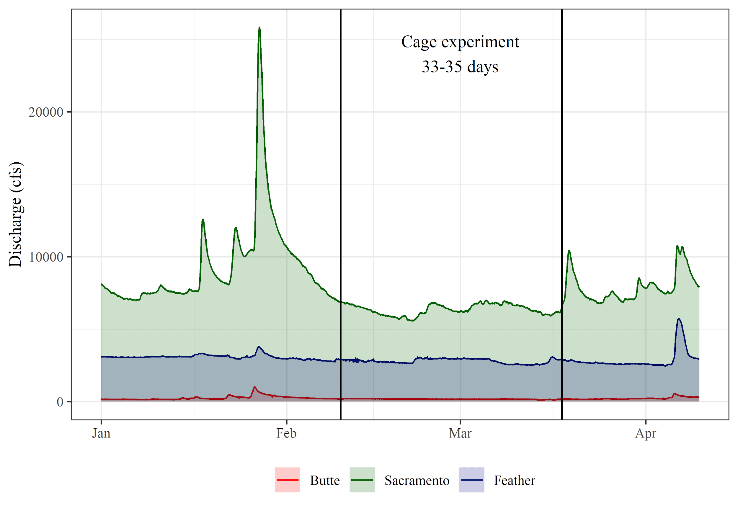

Figure 2. Flow (cfs) measured at Butte City (BTC), Butte Creek at Durham (BCD), and Feather River at Star Bend (FSB) gages from January to April 2020.

Our network of stage loggers in the Sutter Bypass channels showed some small flow pulses (<1,500 cfs) emanating from Butte Creek (Figure 3), but these pulses resulted in limited inundation of off-channel habitat. Off-channel wetland habitat in the Sutter Bypass was confined to the managed wetlands at the Sutter National Wildlife Refuge, Willow Slough wetland in the lower Bypass, and near-channel lowlands in the bean field adjacent to the west-borrow canal immediately south of Highway 20.

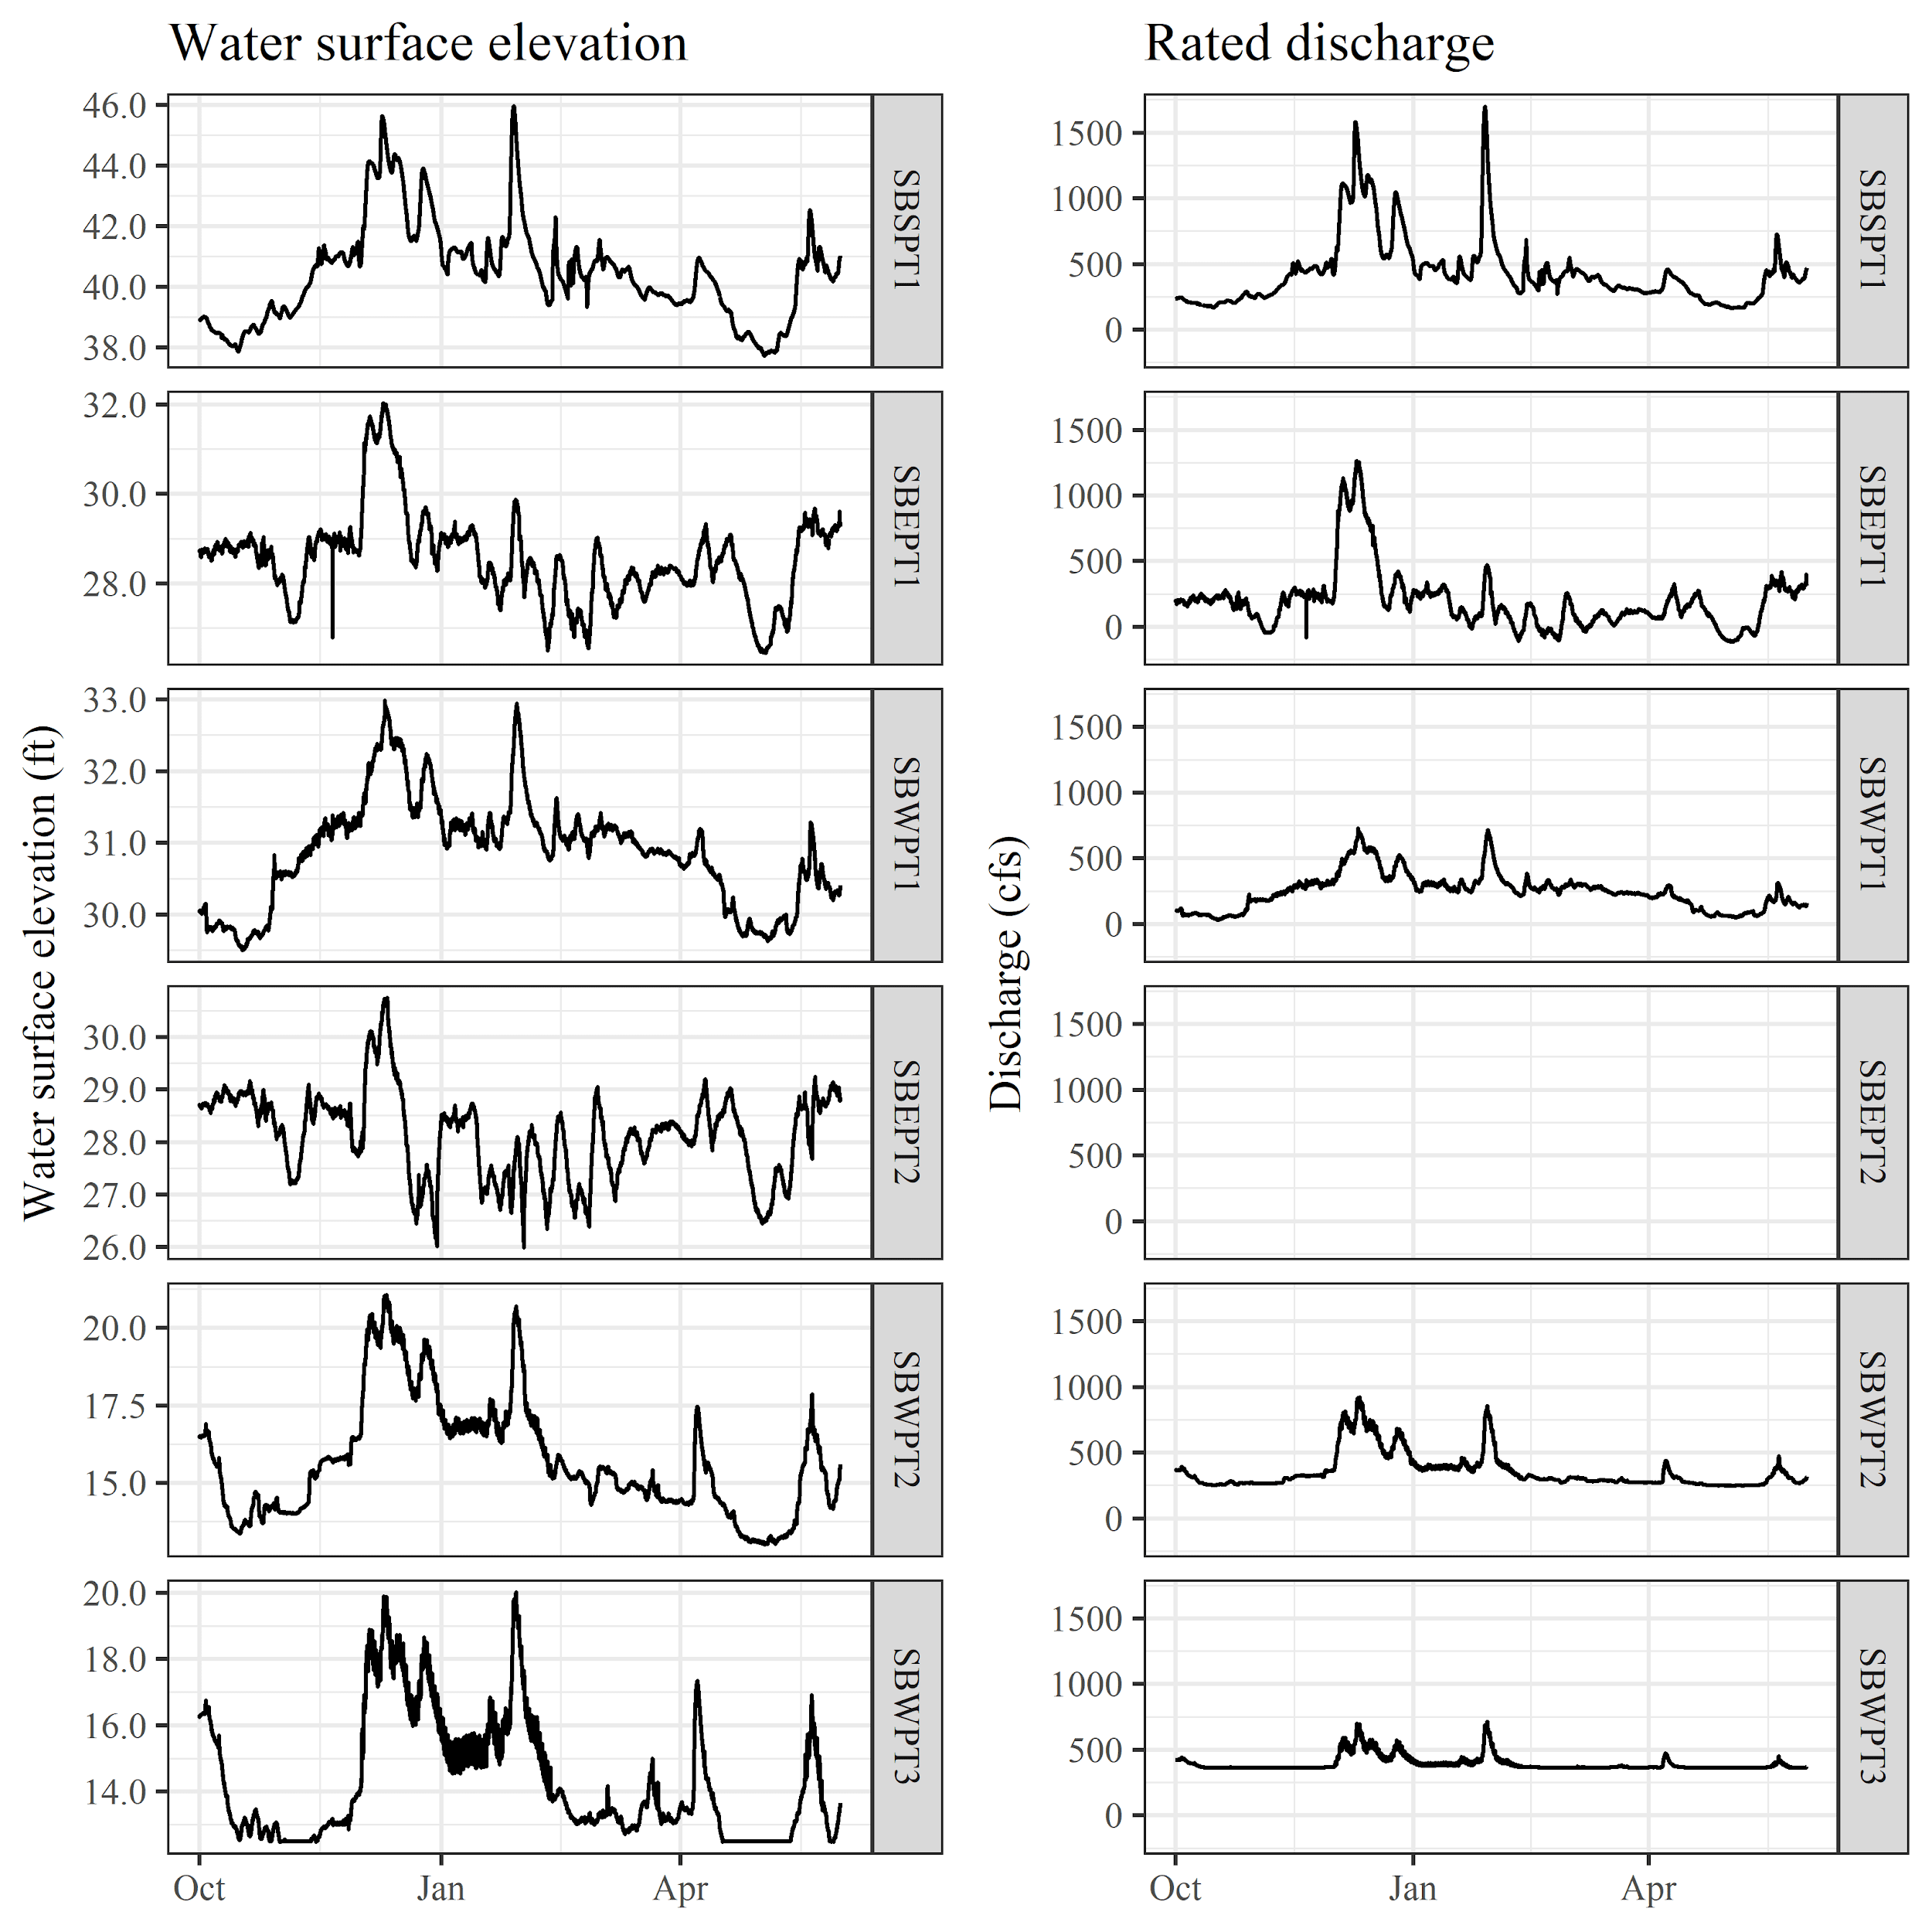Figure 3. Water surface elevation (left) and rated discharge (right) plots from our network of stage loggers in the Sutter Bypass.

Historical trend analysis revealed that extremely dry water years like 2020 with zero qualifying flood events were observed in 2 out of 60 years (3.3%) pre Shasta dam construction and 15 out of 77 years (19.5%) after Shasta dam was built. K-means cluster analysis on individual qualifying flood events in the Sacramento River at Bend Bridge (n = 649) resulted in five distinct flood clusters identified as: 1) early small, 2) late small, 3) goldilocks, 4) long duration, and 5) ravaging (Figure 4A). A series of changes in flood duration and intensity were observed post dam construction (Figures 4B and 4C). For example, there was a complete elimination of ravaging floods post dam construction, which was to be expected given river regulation and maximum spill rates of the dam providing flood protection for the region. An increase in the recurrence interval by approximately double for late small and goldilocks floods was observed. There was also a slight reduction in the recurrence interval for long duration floods, which is presumably a consequence of capturing the large flood pulse peaks (which would have fallen into the ravaging category) and discharging them in a controlled manner later in the flood event or season.

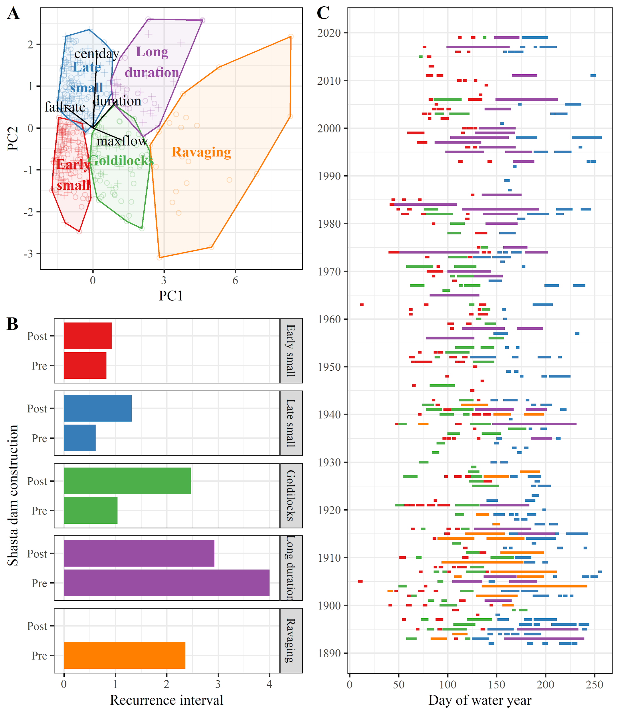

Figure 4: (A) Principal components analysis plot of the first two components (PC1, PC2) grouped by K-means clustering. (B) Recurrence intervals for the 5 flood types identified by K-means clustering. (C) Historical flood type reconstruction for the Sacramento River at Bend bridge daily flow data.

## Water quality

Water temperature was more variable in the wetland sites with larger diurnal fluctuation in values. Channel sites had more consistent temperatures which gradually increased during the course of the experiment (Figure 5A). Similarly, dissolved oxygen showed much more diurnal variation in the off-channel wetlands compared to the river which remained near saturation for the duration of the experiment (Figure 5B). The average diurnal fluctuation in dissolved oxygen flux was 6.38% ± 1.91 SE, 16.1% ± 13.9 SE, and 62.5% ± 35.4 SE in the river channel, canal channel, and wetland habitats respectively.

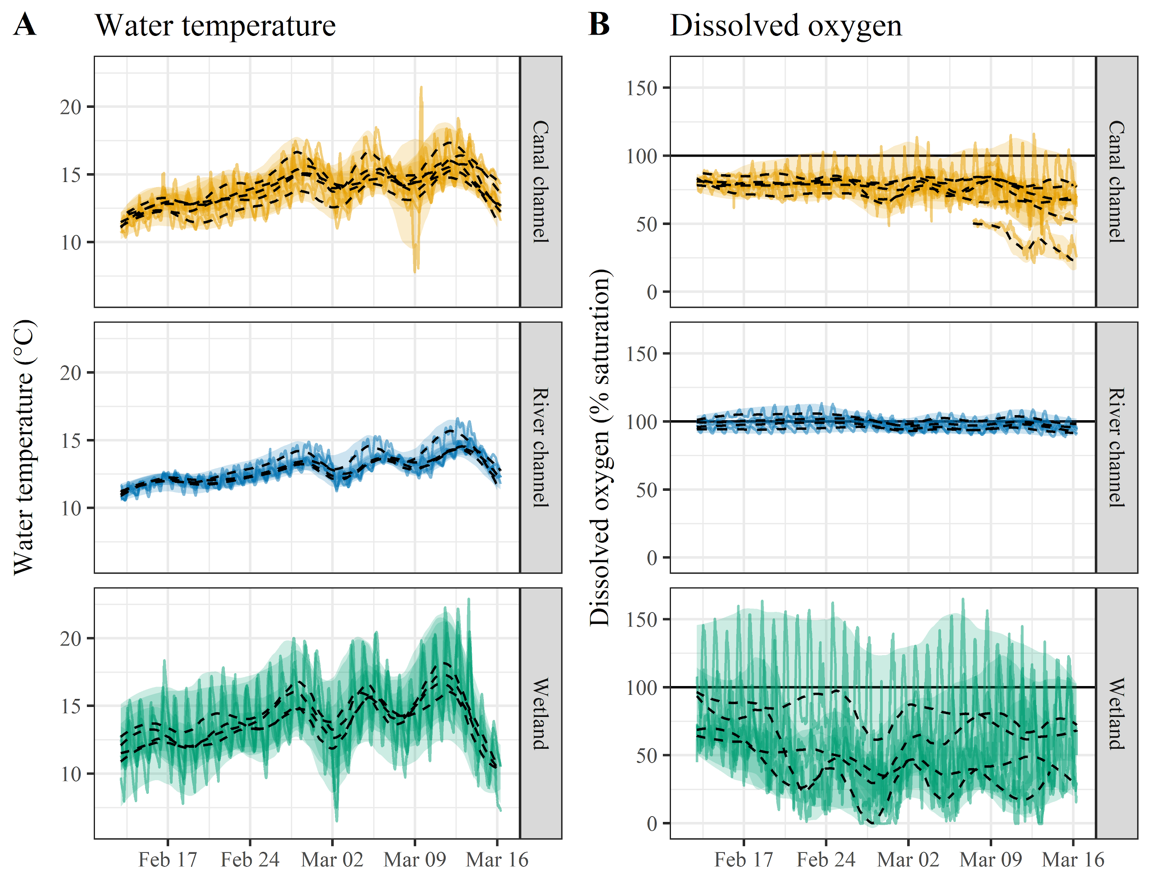

Figure 5. Continuous water temperature (℃) (A), and dissolved oxygen (% saturation) (B) data, at a 15 minute interval and for each cage location. Colored lines indicate the actual data. The black lines show linear regressions (generated with *loess* R function) through the daily mean data for each cage location. Transparent ribbons show daily temperature ranges for each cage location.

We observed differences in conductivity (EC), salinity (Sal), and Turbidity (Turb) among habitat types, indicating differences in residence time (Figure 6). Wetland habitats had higher conductivity and salinity than both river and canal channel habitats indicated by the observed increased concentrations of salts left behind after evaporation in the wetlands which have an increased water residence time. Primary productivity indicators (Blue Green Algae (BGA) and Chlorophyll-a (CHL)) provided a mixed signal across habitat types. BGA and CHL followed a similar trend for each habitat type. pH was larger in river channel habitats. Turbidity also stayed relatively low across all habitats due to the lack of significant flow events in the river.

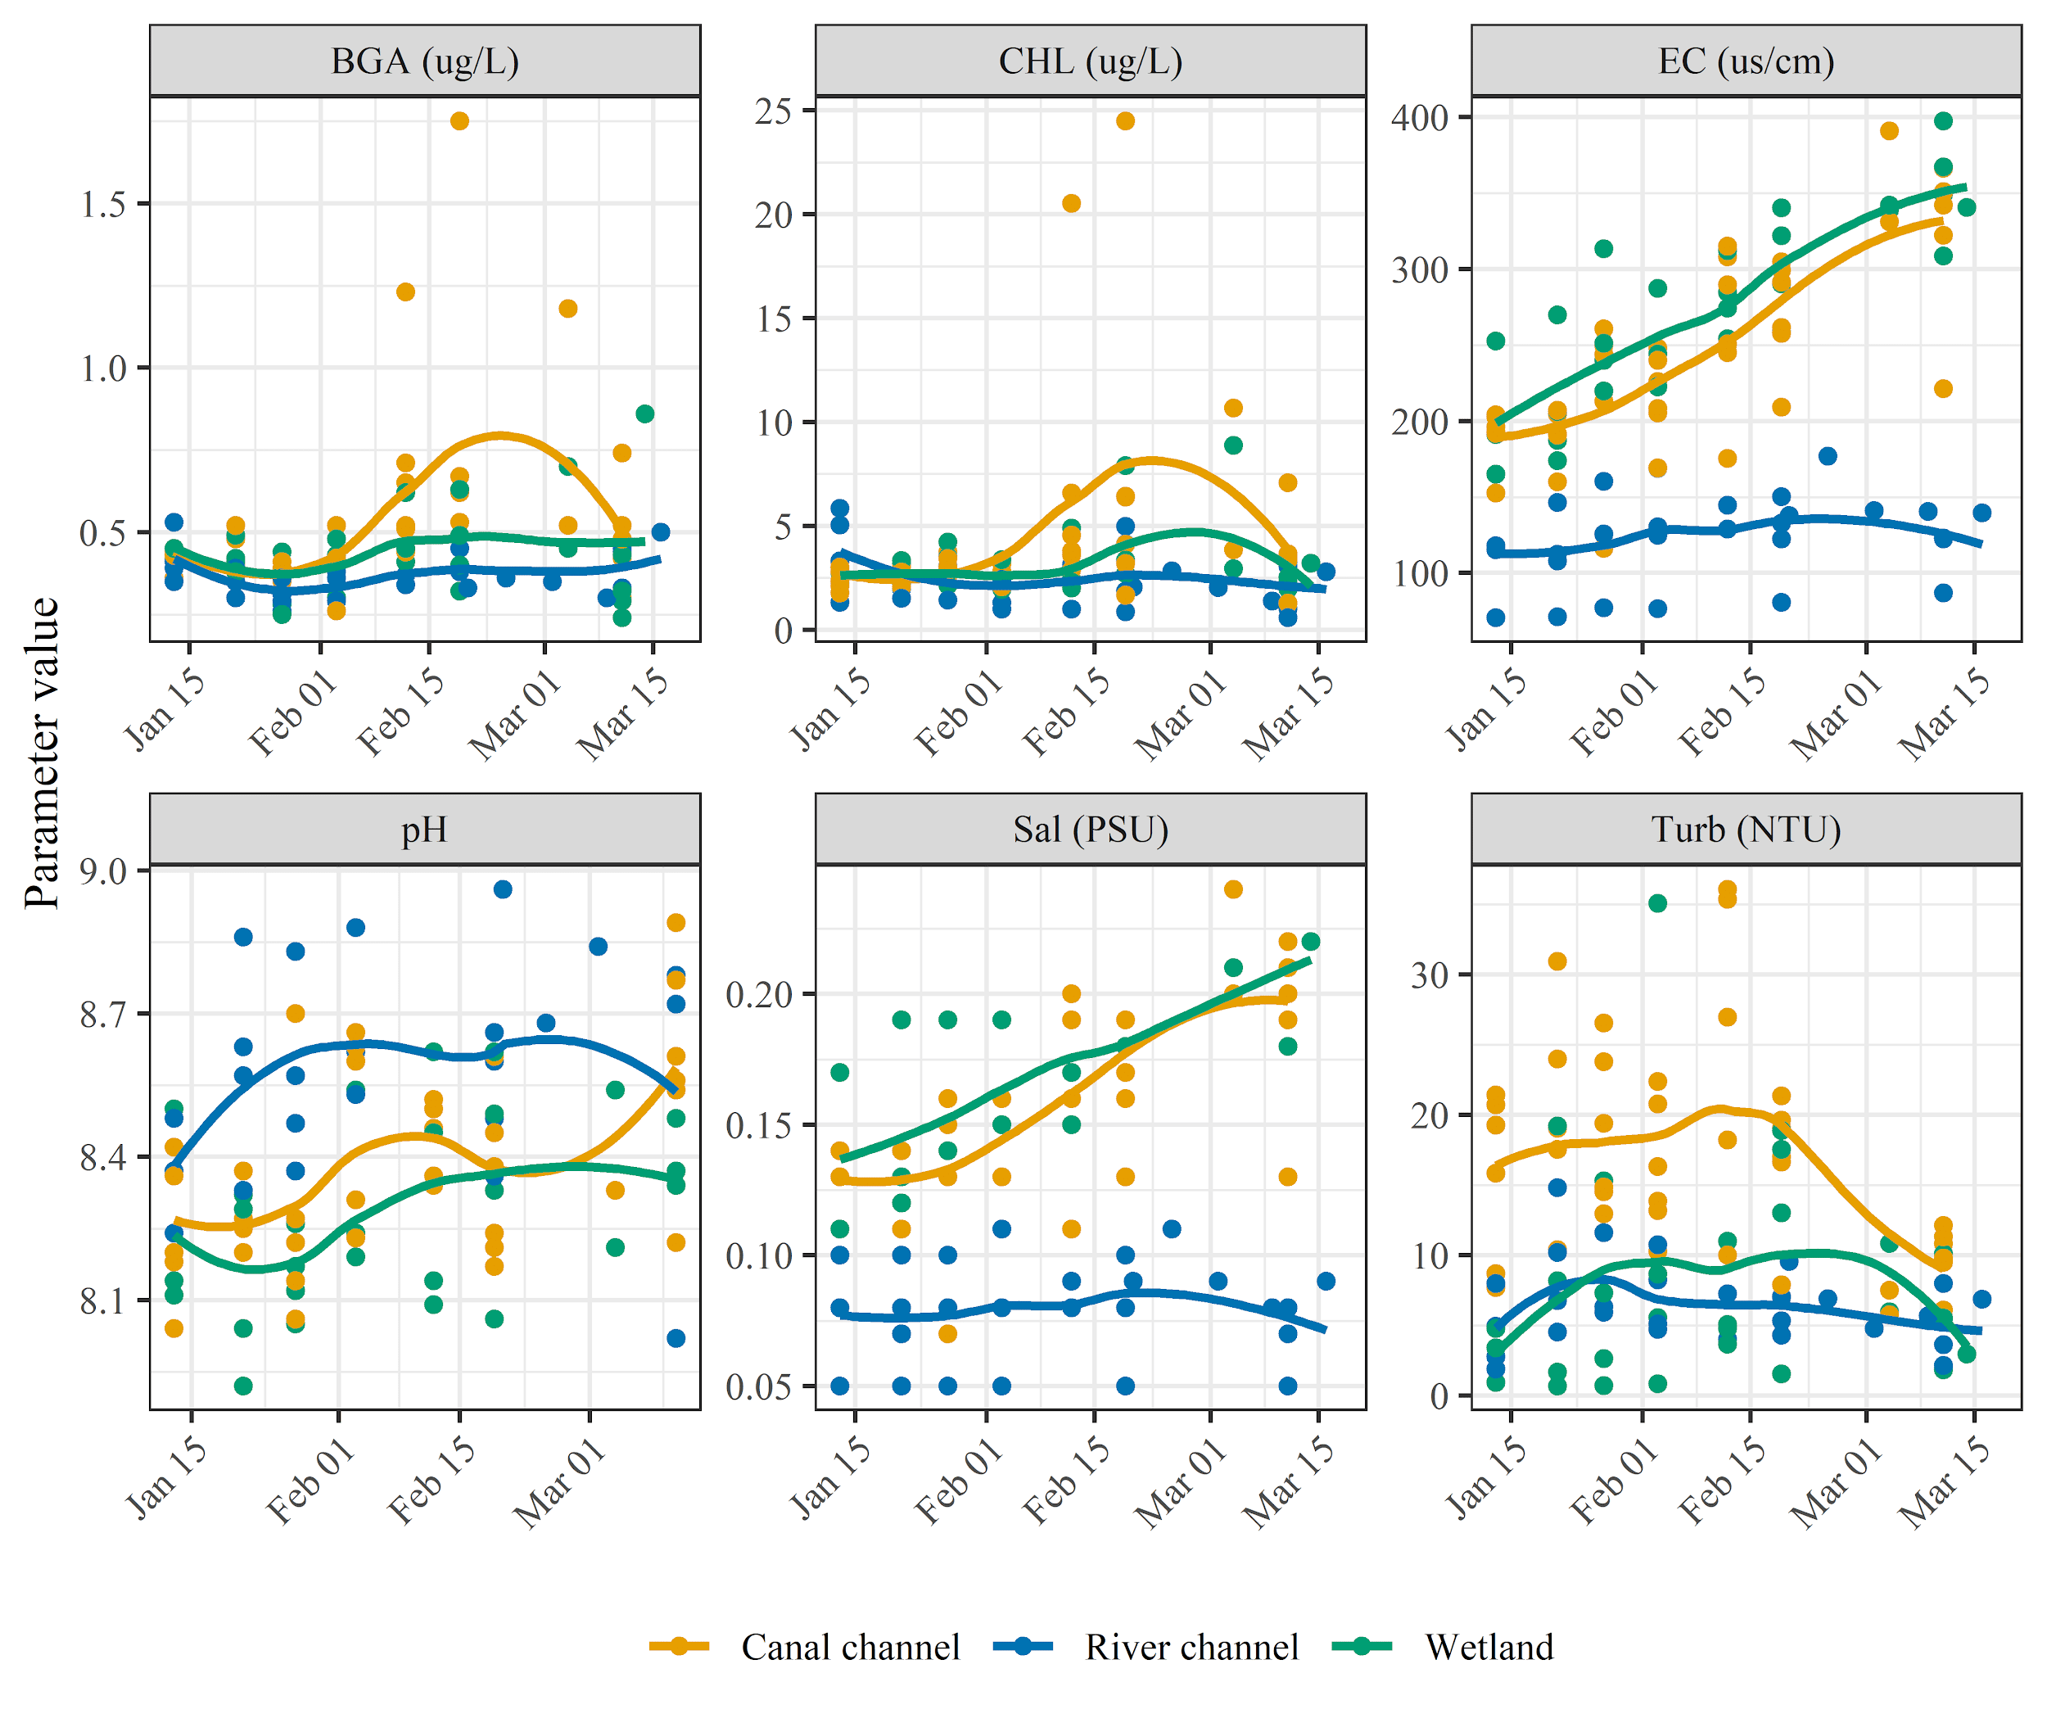Figure 6. Point water quality measurements grouped by habitat type. Colored dots indicate the actual data. The colored lines show linear regressions (generated with *loess* R function) through the weekly water quality measurements for each habitat type.

## Ambient zooplankton abundance and composition

Higher zooplankton densities were observed in wetland cage locations, in comparison to channel locations (Figure 7A). Canal channels generally had higher concentrations of zooplankton than river channels. There was a slightly increasing zooplankton density trend later in the season, across all habitat types.

Zooplankton community analysis showed distinct separation of habitat types. Wetland communities were distinguished by high densities of large bodied cladoceran species. Canal channel communities were defined by a community including species of small bodied cladocera species. River channel cage locations were defined by low densities of cladocera and rotifera but had higher densities of insects. Copepods were more ubiquitous to all locations, but wetland habitats had much higher densities than channel habitats (Figures 7B and C).

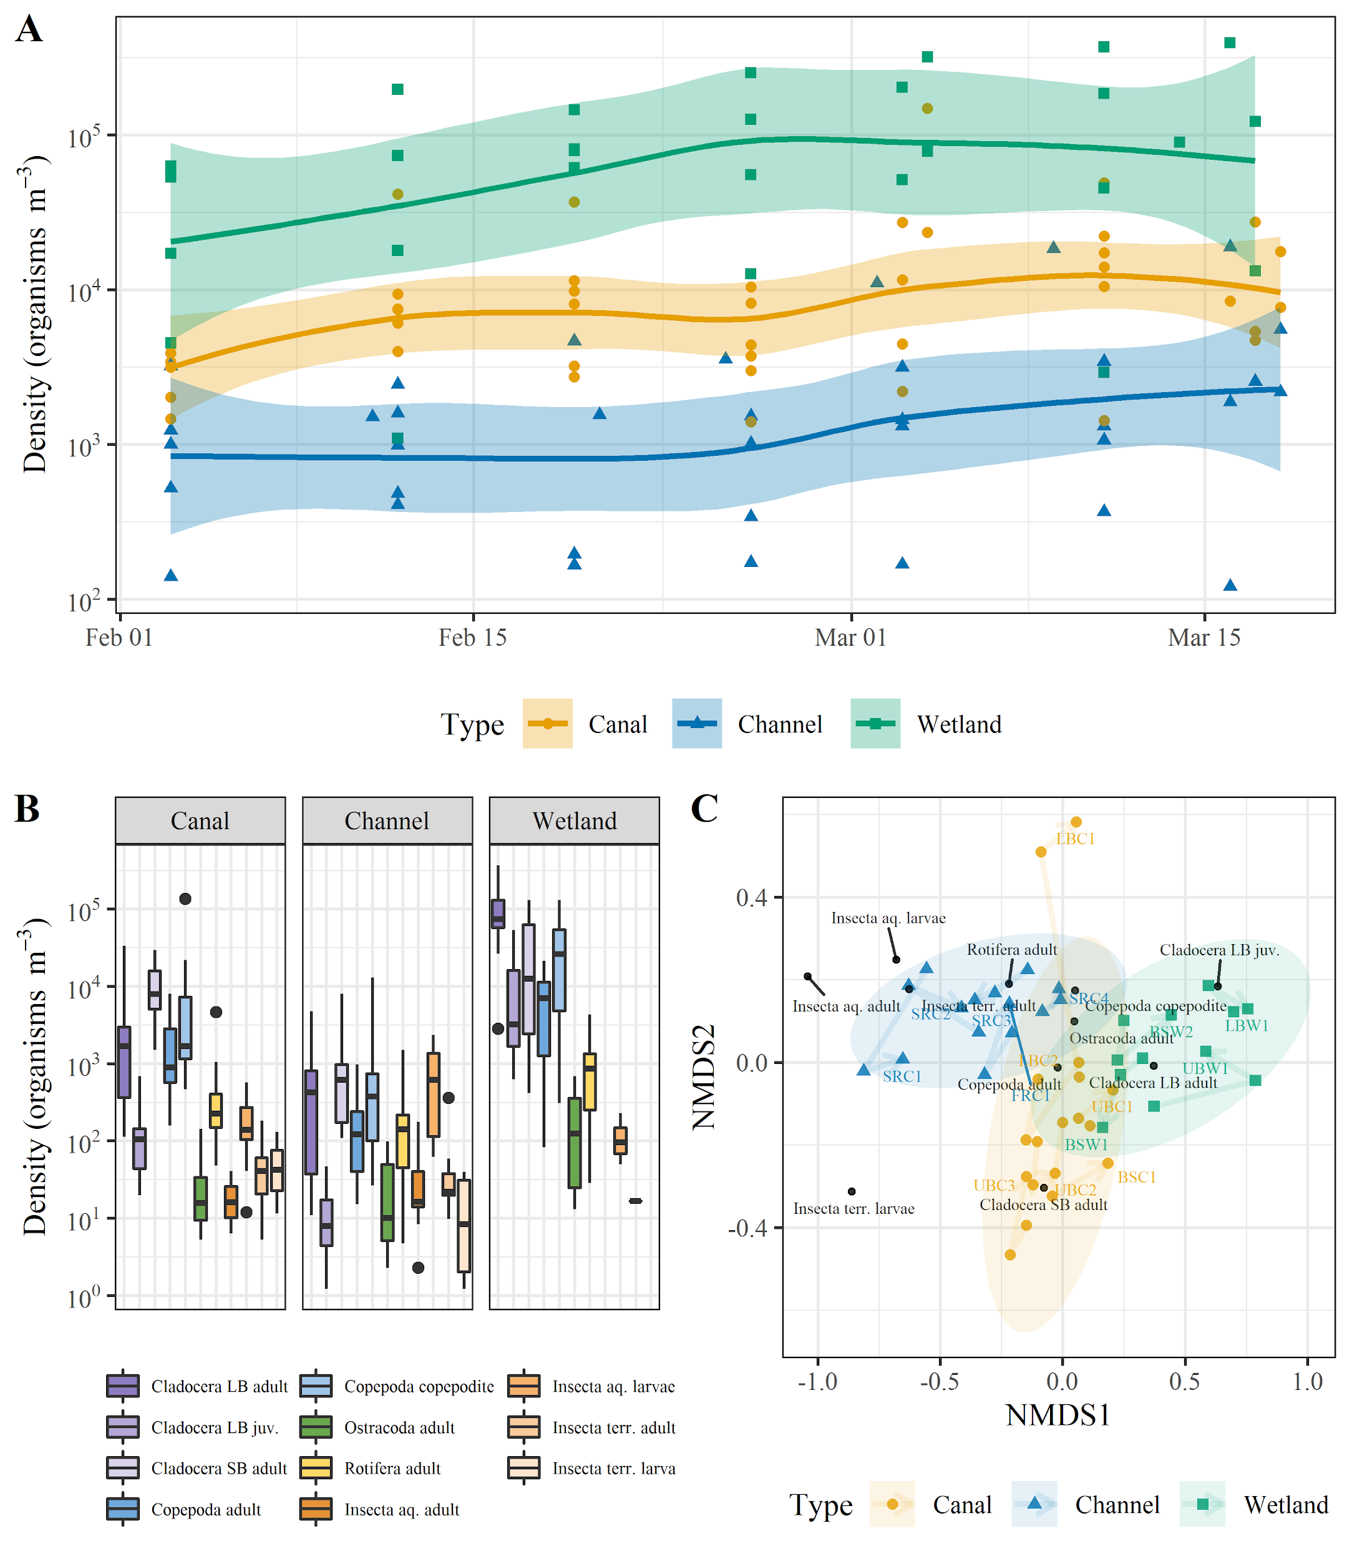

Figure 7. (A) Trends in total zooplankton abundance grouped by habitat type on a logarithmic scale. Colored dots indicate the actual data. The colored lines show linear regressions (generated with *loess* R function) through the weekly zooplankton density estimates for each habitat type. Transparent ribbons show weekly zooplankton density ranges for each habitat type. (B) Boxplots of zooplankton density grouped by operational taxonomic units (OTU) for each habitat type on a logarithmic scale. (C) NMDS plot of ambient zooplankton assemblages, colored by habitat type.

## Cage salmon’s diet abundance and composition

Wetland cage fish diet was generally composed of higher prey weights than in channel habitats (Figure 8A). The only exception was at BSW2 which had comparable prey weights to channel fish diets. Caged fish in river channel locations situated downstream of known off-channel effluent points (i.e., SRC2, SRC3, SRC4) had prey compositions with more cladocera and copepods than did fish from channel locations above these inputs (i.e., SRC1, FRC1) which were composed primarily of insects (Figures 8B and C).

Tight grouping of wetland cage locations driven by amphipods and cladocera dominated diets was observed (Figure 8D). Canal channel habitats showed a copepod and small cladocera dominated diet. The River channel locations were split between “headwater” and “off-channel subsidized” groupings where the latter had evidence of increased zooplankton dependence likely from off-channel inputs.

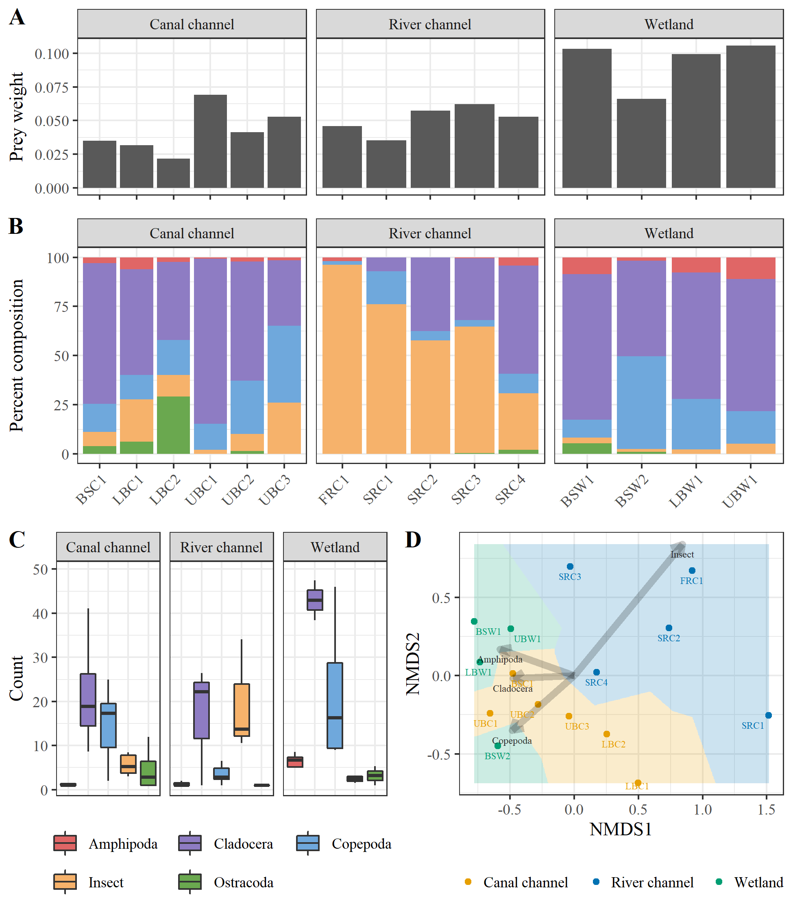

Figure 8. (A) Prey weight summary for each cage fish diets, grouped by habitat type. (B) Percent composition of caged fish gut OTUs grouped by habitat type. (C) Boxplots showing quantiles of stomach content counts colored by OTU category and grouped by habitat type. (D) NMDS plot of caged fish gut compositions at the end of the experiment colored by habitat type.

## Cage salmon’s growth

Initial fork length (mm) and weight (g) at the time of stocking for the growth cage salmon was 51.1 +/- 2.7 mm SD and 1.39 +/- 0.25 g SD. At the end of the 5 week experiment, size ranged from 54.4 +/- 2.6 mm SD and 1.52 +/- 0.32 g SD at BSC1 (Butte Creek at Gridley Rd.) to 84.75.7 +/- 6.7 mm SD and 7.15 +/- 1.59 g SD at UBW1 (Sutter Bypass refuge wetland; Figures 10A and B). Percent change in fork length and weight ranged from 5.2% and 10.8% respectively at SRM3 to 66.8% and 409.7% respectively at UBW1.

Following the zooplankton densities trend, caged fish growth was observed to be larger in wetland than channel habitats, with the higher growth found in the upper Sutter Bypass region (Figure 10C). The average daily growth rates ranged from 0.08 mm/day and 0.004 g/day at BSC1 to 0.98 mm/day and 0.17 g/day at UBW1.

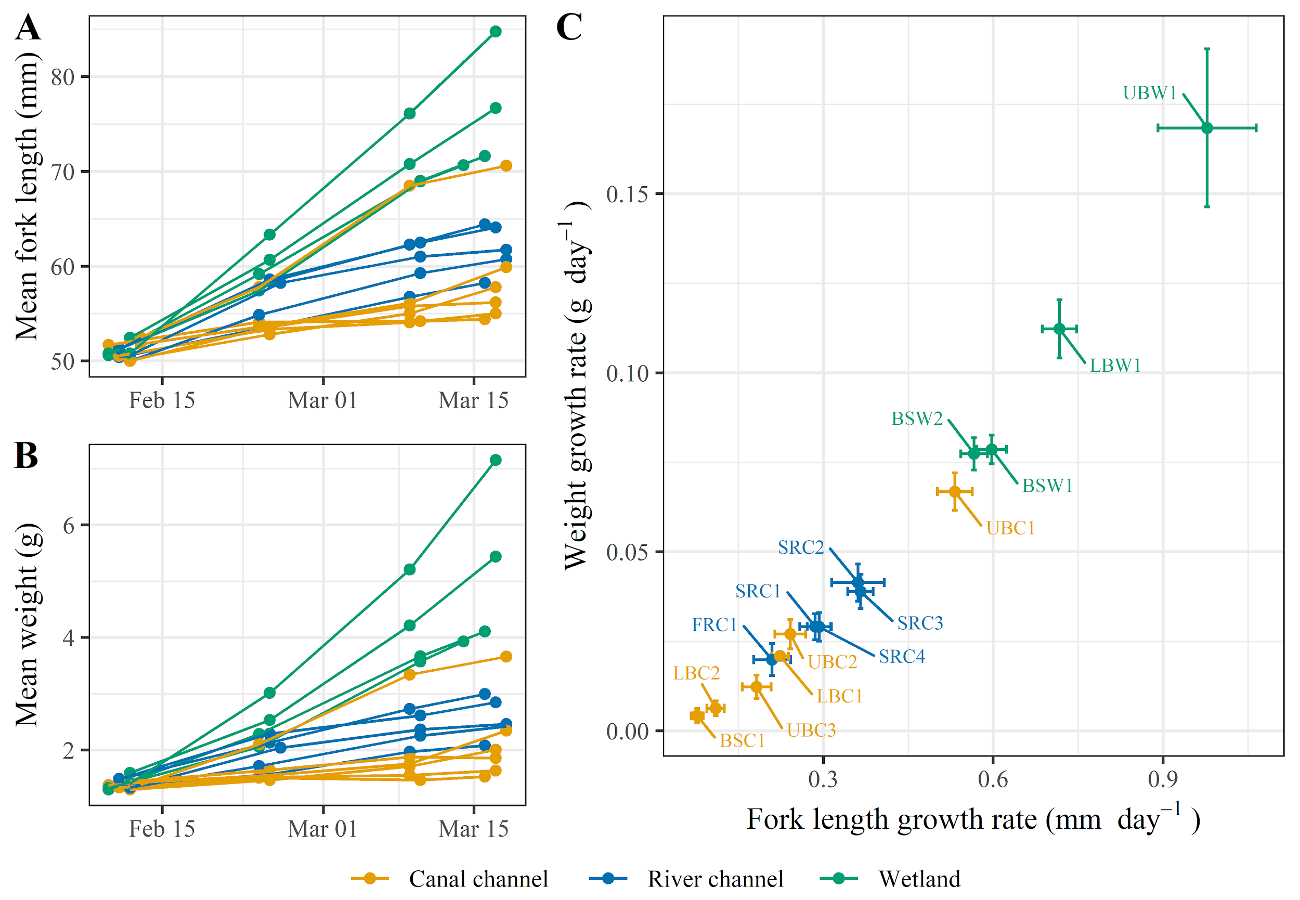

Figure 10. (A) Mean fish size (mm) time series, (B) mean fish weight (g) time series, and (C) mean daily growth rate biplot for each cage location, and colored by habitat type.

## 

A statistically significant effect of habitat type on the mean daily growth rates was found from the ANOVA test (p-value <2e-16). Some growth variability was also observed across regions. In particular, in canal and wetland habitats, growth was overall higher in the Upper Sutter Bypass and lower in the Butte Sink (Figure 11).

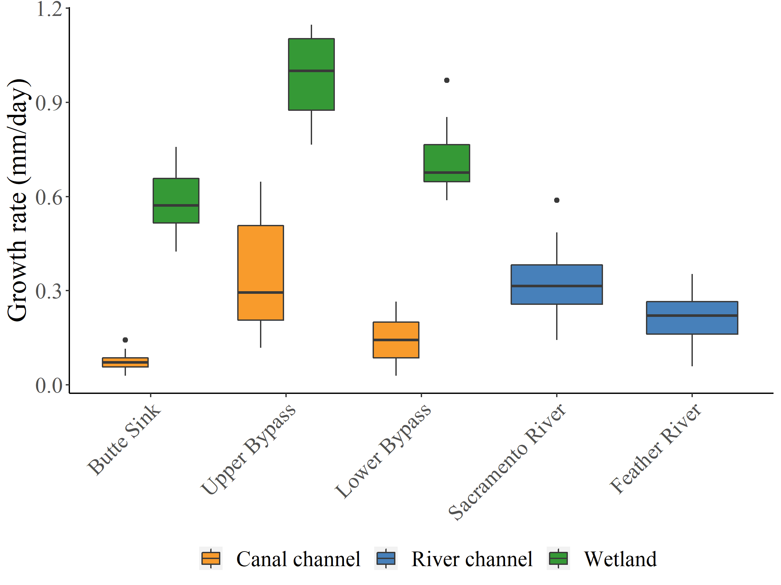

Figure 11. Mean daily fish growth rates (mm/day) boxplot grouped by region and habitat type.

Out of all the factors tested in the modelling exercise, bi-weekly DO range (DOrange) was the variable that best described fish growth (Table 4). In addition, density of large Cladocera, temperature range and range squared, and mean EC had a significant influence on fish growth either acting by themselves or by interacting with one of the other important factors (Table 4; models with ΔAIC < 4). Those results also suggest that potential non-linear relationships exist between DO & temperature ranges, large Cladocera density, and fish growth. Larger DO and temperature ranges, mean EC and large Cladocera density were correlated with higher growth (Figure 12).

Table 4.Comparison of FL growth rate mixed effect models, with habitat type used as a random variable. K= number of model parameters; AICc = Akaike’s information criterion corrected for small sample size; ΔAICc = difference in AICc score between the given model and the most parsimonious model. Models are ordered from lowest to highest AICc. Lower AICc scores indicate greater relative model parsimony.

|  |  |  |  |  |
| --- | --- | --- | --- | --- |
| **Model** | **K** | **AICc** | **ΔAICc** | **AICcWt** |
| dorange +1|Type | 4 | -8.24661 | 0 | 0.24711 |
| dorange + logcladoceralarge+1|Type | 5 | -7.87142 | 0.375193 | 0.204841 |
| dorange +dorange² +logcladoceralarge+1|Type | 6 | -5.88958 | 2.357031 | 0.076044 |
| temprange + logcladoceralarge+1|Type | 5 | -5.64452 | 2.602089 | 0.067275 |
| dorange + meanec+1|Type | 5 | -5.51957 | 2.727043 | 0.0632 |
| temprange+1|Type | 4 | -5.40714 | 2.839469 | 0.059746 |
| dorange +dorange²+1|Type | 5 | -5.38809 | 2.85852 | 0.059179 |
| dorange + temprange+1|Type | 5 | -5.34726 | 2.899355 | 0.057983 |
| temprange +temprange² + logcladoceralarge+1|Type | 6 | -4.39055 | 3.856061 | 0.035938 |
| dorange +dorange²+meanec+1|Type | 6 | -3.86815 | 4.378465 | 0.027677 |
| temprange +temprange²+1|Type | 5 | -3.71939 | 4.527222 | 0.025693 |
| temprange + meanec+1|Type | 5 | -3.71915 | 4.527464 | 0.02569 |
| meanec+1|Type | 4 | -2.17944 | 6.067169 | 0.011897 |
| logcladoceralarge + meanec+1|Type | 5 | -0.68456 | 7.562048 | 0.005634 |
| meanec +meanec² +dorange +dorange²+1|Type | 7 | -0.3516 | 7.895007 | 0.00477 |
| logcladoceralarge+1|Type | 4 | -0.0543 | 8.192316 | 0.004111 |
| meando+1|Type | 4 | 0.682296 | 8.928907 | 0.002844 |
| meanec +meanec² +temprange+ temprange²+1|Type | 7 | 0.765429 | 9.012041 | 0.002729 |
| meanec +meanec²+1|Type | 5 | 0.807772 | 9.054383 | 0.002672 |
| 1+1|Type | 3 | 1.383932 | 9.630544 | 0.002003 |
| meantemp+1|Type | 4 | 1.904565 | 10.15118 | 0.001544 |
| meanec +meanec² +logcladoceralarge+1|Type | 6 | 2.163267 | 10.40988 | 0.001356 |
| meanturb+1|Type | 4 | 2.648848 | 10.89546 | 0.001064 |
| logterrinsect+1|Type | 4 | 2.94222 | 11.18883 | 0.000919 |
| logaquaticinsect+1|Type | 4 | 3.295019 | 11.54163 | 0.00077 |
| meanchl+1|Type | 4 | 3.505436 | 11.75205 | 0.000693 |
| meantemp+meantemp²+1|Type | 5 | 3.634344 | 11.88096 | 0.00065 |
| meando +meando²+1|Type | 5 | 3.647972 | 11.89458 | 0.000646 |
| logostracoda+1|Type | 4 | 3.722638 | 11.96925 | 0.000622 |
| lograre+1|Type | 4 | 3.791695 | 12.03831 | 0.000601 |
| logrotifera+1|Type | 4 | 4.019713 | 12.26633 | 0.000536 |
| logcopepoda+1|Type | 4 | 4.033532 | 12.28014 | 0.000532 |
| meanph+1|Type | 4 | 4.092577 | 12.33919 | 0.000517 |
| logcladocerasmall+1|Type | 4 | 4.119439 | 12.36605 | 0.00051 |

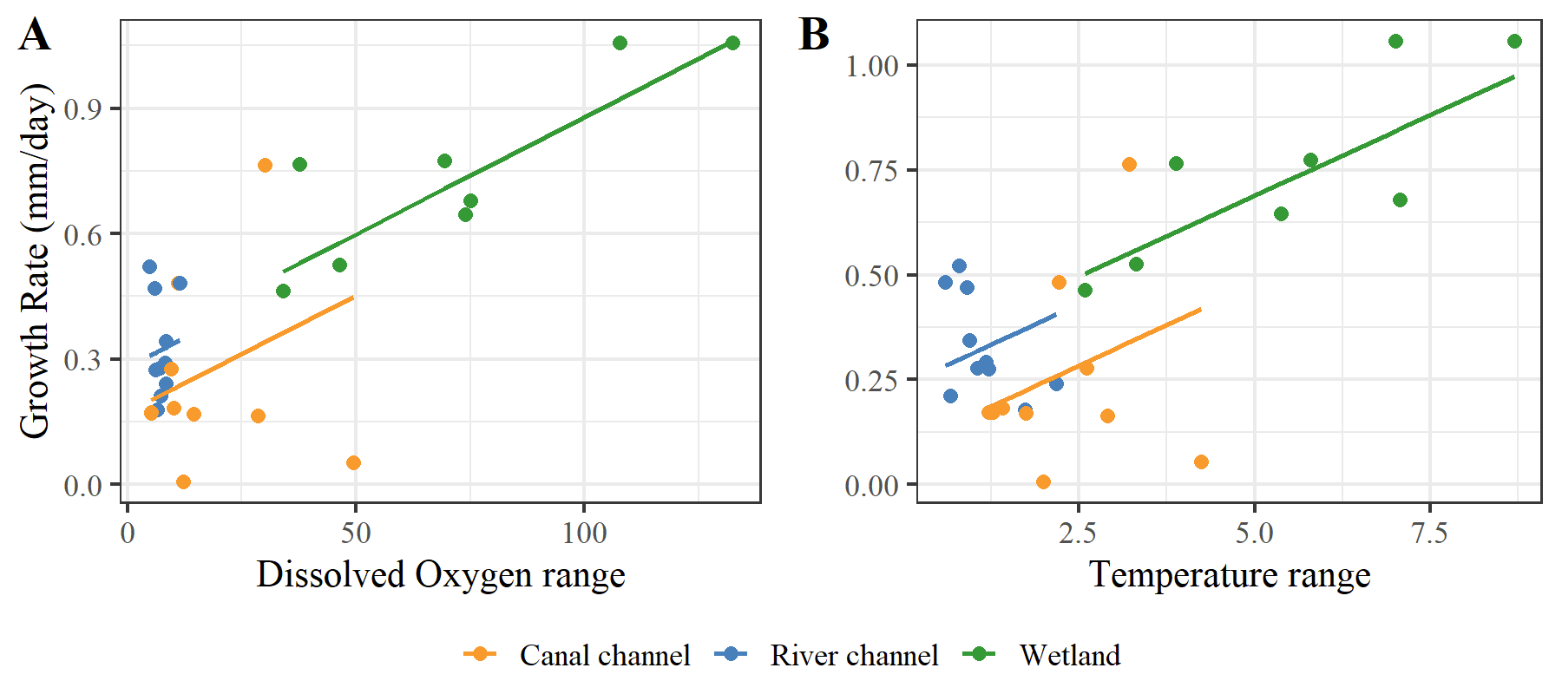Figure 12. Relationships between caged fish mean daily growth rate (mm/day) and (A) temperature range, (B) dissolved oxygen, by habitat type. The dots represent the raw data, and the lines show habitat specific growth rate predictions from the mixed effects model.

## Wild fish sampling

Various native and non-native fish species were caught during the wild fish sampling events (Table 5). Among them several juvenile spring- and fall-run Chinook Salmon were sampled (Figure 13). Salmon run identification is currently based on the Length-At-Date criteria, as genetic identification has been delayed due to COVID-19 shutdown and no completion date is available at the moment.

Table 5. Fish species caught during the wild fish sampling events.

|  |  |  |  |  |  |  |  |  |  |
| --- | --- | --- | --- | --- | --- | --- | --- | --- | --- |
| Species | Common name | Butte Sink wetland | | | | Refuge | | | Total |
| 4-Feb | 20-Feb | 3-Mar | 14-Mar | 4-Feb | 20-Feb | 4-Mar |
| Ameiurus nebulosus | Brown bullhead | 0 | 0 | 0 | 0 | 0 | 0 | 1 | 1 |
| Cottus asper | Prickly sculpin | 0 | 1 | 0 | 0 | 0 | 0 | 0 | 1 |
| Gambusia affinis | Western mosquitofish | 0 | 0 | 0 | 5 | 2 | 0 | 1 | 8 |
| Lepomis cyanellus | Green sunfish | 0 | 0 | 0 | 0 | 0 | 0 | 2 | 2 |
| Lepomis gulosus | Warmouth | 0 | 0 | 0 | 0 | 0 | 0 | 1 | 1 |
| Lepomis macrochirus | Bluegill | 2 | 0 | 0 | 0 | 4 | 1 | 5 | 12 |
| Notemigonus crysoleucas | Golden shiner | 9 | 0 | 0 | 0 | 4 | 0 | 5 | 18 |
| Oncorhynchus tshawytscha | Chinook Salmon | 22 | 12 | 12 | 13 | 0 | 6 | 4 | 69 |
| Percina macrolepida | Bigscale logperch | 0 | 0 | 0 | 0 | 0 | 5 | 3 | 8 |
| Pomoxis nigromaculatus | Black crappie | 1 | 0 | 0 | 0 | 5 | 0 | 6 | 12 |

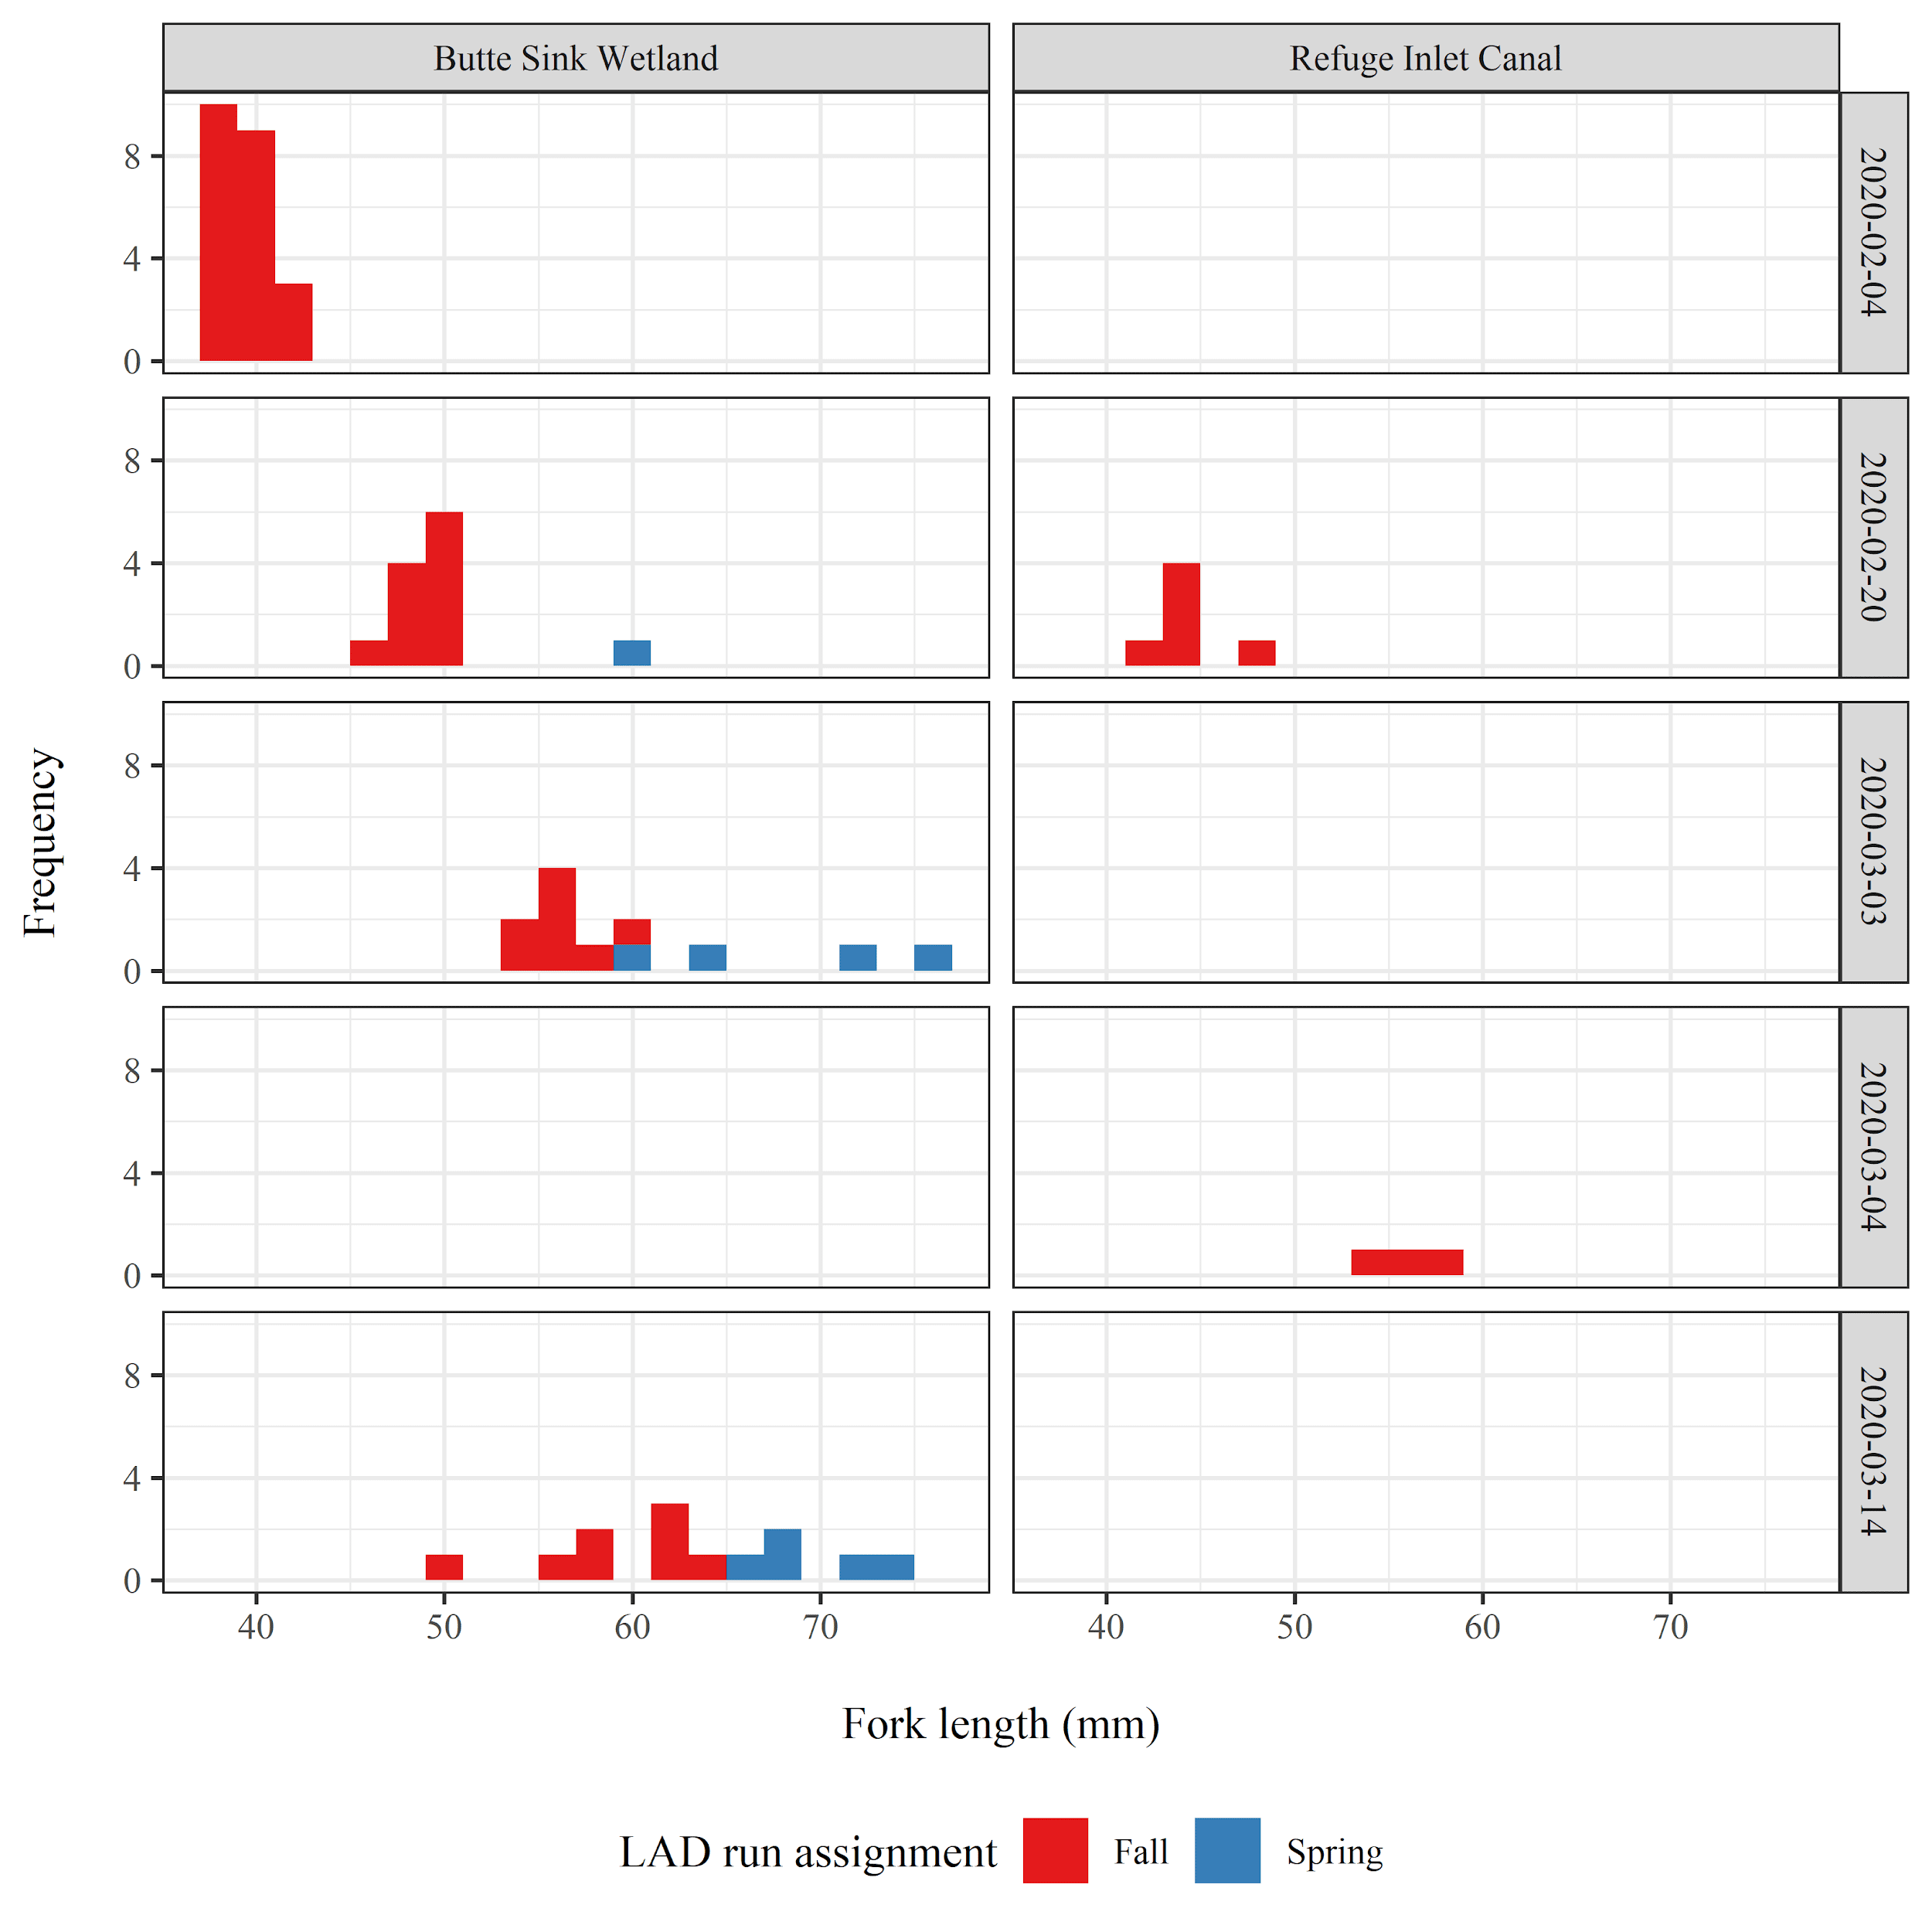

Figure 13. Number of juvenile Chinook Salmon caught during the wild fish sampling events, colored by run type. Length-At-Date (LAD) criteria was used here for Chinook Salmon run identification.

## Caged versus wild salmon diet and growth rate

The low and stable hydrologic conditions presented a unique opportunity to monitor apparent growth rates and diets of a semi-contained population of wild Chinook Salmon in a Butte Sink Wetland. The low flows in the adjacent Sanborn Slough meant that fish that were in the wetlands entered in early February and while they presumably could have exited the wetland, we sampled the population at a bi-weekly interval concurrent with the deployment of caged salmon. This allowed us to compare growth rates and diets of wild and experimental caged fish residing in the same wetland for an extended period of time.

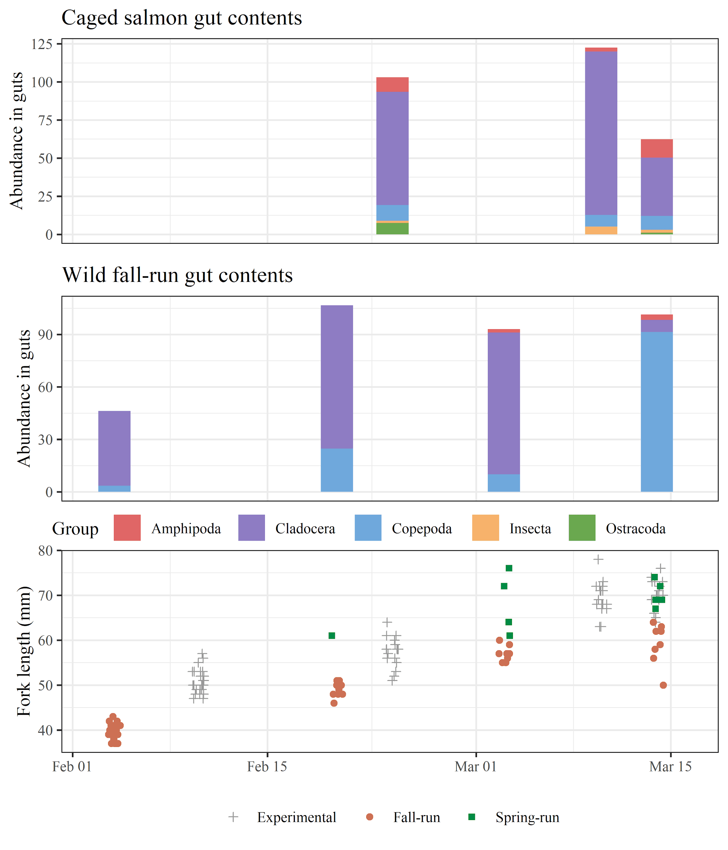

Figure 14. Zooplankton composition and abundance found in (A) caged fish diet and (B) wild fall-run Chinook diet. (C) Measured size (mm) of caged and wild salmon through time.

# DISCUSSION

pH was larger in river channel habitats likely due to a combination of nutrient limitations, and grazing pressure by secondary producers (filter feeding zooplankton).

Turbidity spikes in the wetlands are often due to congregations of waterfowl or wind events. These localized events can cause spikes in observed turbidity in canal channel sites downstream of effluent points.

The habitat-specific growth rate results are very similar to what was observed in 2019. Zooplankton densities were not influencing bi-weekly growth rates in 2020, different from 2019. Temperature plays a role in both years and DO that was not measured continuously in 2019 is seen to play an important role in 2020. The counterintuitive result; wider DO range leads to higher growth might be due to DO range being so wide for wetlands where growth is much larger than in other habitat types, and this correlation might drive the modelling results.

Wetland cage fish diet was generally composed of higher prey weights than in channel habitats (Figure 13, top panel). The only exception was during cage termination at BSW2 which had comparable prey weights to channel fish diets. This could be due to higher gut evacuation rates associated with higher water temperatures.

The River channel locations were split between “headwater” and “off-channel subsidized” groupings where the latter had evidence of increased zooplankton dependence likely from off-channel inputs. These subsidized river sites also generally correlated with higher growth rates (except for BSC1)

Wetland cage fish diet was generally composed of higher prey weights than in channel habitats (Figure 13, top panel). The only exception was during cage termination at BSW2 which had comparable prey weights to channel fish diets. Caged fish in river channel locations situated downstream of known off-channel effluent points (i.e., SRC2, SRC3, SRC4) had prey compositions with more cladocera and copepods than did fish from channel locations above these inputs (i.e., SRC1, FRC1) which were composed primarily of drift invertebrates (Figure 13, bottom panel). Caged fish at UBC1, which was located close to the Butte Sink wetlands, had higher quantities of cladocera in their diets than fish from canal cages located further downstream from the wetlands. These findings show that productivity can be exported from off-channel sites to channel habitats, but that the subsidy depletes over distance downstream of input.

Food web development in the off-channel Butte Sink and Sutter Bypass habitats was significantly higher than the adjacent channel habitats. Numbers of zooplankton were often 10 to 100 times more abundant in the off channel habitats compared to the river channels (Figure 8). The off-channel habitats consisted of both flooded wetlands, primarily duck clubs and the Sutter National Wildlife Refuge, as well as flooded agricultural fields (rice, corn, and other row crops). These habitats generally had higher residence times as highlighted by higher SPC, salinity, and chlorophyll-a values (Figure 6). The exception to this was when there were high flow events when all of the weirs in the Sutter Bypass were being overtopped and the Sutter Bypass water quality looked similar to that of the Sacramento River. During high flow events, the vast majority of the water moving down the Sacramento River is routed through the flood bypass system, as such reducing water residence time on the off-channel locations. As these high flow events receded, velocities slowed on the bypasses and residence times increased resulting in high zooplankton abundances following those events. These same processes have been observed in the downstream Yolo Bypass (Sommer et al. 2001) and relatively natural Cosumnes River floodplain (Ahearn et al. 2006, Grosholz and Gallo 2006, and Jeffres et al. 2008). The high abundances of zooplankton that constitute the lower trophic levels following flooding events create the opportunity for high growth rates for the variety of fishes that utilize the floodplains.

Fish that were placed on the off-channel habitats had significantly higher growth rates compared to those placed in riverine channel habitats (Figure 13). This was likely a consequence of access to abundant food resources as well as warmer temperatures compared to the river channel sites. When food resources are abundant and temperatures are higher, yet within biological thresholds, growth rates can be quite high (Lusardi et al. 2019). This is similar to other studies in floodplains in the Central Valley where similar water conditions and food resources have been observed resulting in relatively high growth rates for juvenile Chinook Salmon (Sommer et al. 2001, Jeffres et al. 2008, Katz et al. 2017). We built a mixed-effects model looking at physical and ecological variables in relation to fish growth in all of our regions and habitat types. Zooplankton abundance was the most important factor in determining fish growth regardless of habitat type or region. There was a linear relation with zooplankton density and fish growth and as such, the Butte Sink and Sutter Bypass, which had the highest zooplankton density, had the highest fish growth. River site where zooplankton abundance was low saw relatively slow growth rates. The type of habitat where fish were located also seemed to have a stronger influence on growth rate compared to the region. Additional years of data under different flow conditions will help to better assess the influence of habitat type versus region on fish growth.

In addition to variation in water quality regionally and between habitat types, we observed lateral banding from west to east within the Bypass, which might also influence fish growth within a given habitat type. Water sources from Butte Creek, Colusa Weir, Tisdale Weir during moderate flow conditions did not laterally mix and would remain “banded” through the Sutter Bypass (Figure 20). This could influence the water quality and food within a habitat over space and time. Because our fish were caged in a single location and not able to move freely through the habitat the results must be taken in this context. This was most evident at the LBA2 location on the west side of the lower Sutter Bypass. This location, during moderate flows, had water quality conditions similar to that of the Tisdale Weir because as water entered the Sutter Bypass from Tisdale Weir it remained along the west side of the Bypass flowing downstream. In contrast, at this same habitat on the east side of the bypass, the water conditions were different. This same band of water just upstream at LBA1, on the east side of the bypass had different water quality parameters and higher abundances of zooplankton. Wild fish that could move freely through the habitat could potentially optimize the benefits of the lateral variability zooplankton abundances.

All four runs of juvenile naturally migrating Chinook Salmon were collected in either Butte Sink or Sutter Bypass during the 2019 sampling effort. The late-fall run fish that were captured were all adipose clipped suggesting that they were hatchery fish released from Coleman National Fish Hatchery and utilizing the Sutter Bypass during their out-migration to the ocean. The fact that all four runs of juvenile salmon were collected from January through April highlights the potential habitat utilization for Central Valley Chinook Salmon. This also highlights the complexities of how fish can move through the watershed and how and when various habitats are available. 2019 was a wet year with extensive flooding. “Normal” water years do not have nearly the availability of habitats to all four runs of Chinook Salmon. It is likely that both spring-run and fall-run Butte Creek juveniles have access to at least flooded wetland in the Butte Sink due to current wetland management practices that keep the wetlands flooded until April to mitigate noxious weed growth. These habitats may function until April in a cool, wet year as we saw in 2019, but in warm dry conditions it is possible that these habitats may not be as beneficial as we observed during this study. Being able to collect data across a variety of years and water year types will help to tell a better story of how the Butte Sink and Sutter Bypass function across a variety of hydrological conditions. These data will provide information to resource managers to think more holistically about how managed off-channel habitats can benefit juvenile salmon across all water year types.

# ACKNOWLEDGEMENTS

Funding for this project was provided by the US Fish and Wildlife Service through a Central Valley Project Improvement Act (CVPIA) grant, agreement number: F19AC00062. In addition, we would like to acknowledge the California Department of Water Resources for funding a concurrent project that enhanced the work that could be done on this project. We also would like to thank Sutter Mutual Water Company, US Fish and Wildlife Service, California Waterfowl Association, Motna Farms, and Lundberg Family Farms for site access and project support.

# REFERENCES

Akaike, H. 1973. Information theory as an extension of the maximum likelihood principle. In: 2nd International Symposium on Information Theory (Ed. by B.N. Petrov and F. Csaksi), pp. 267–281. Akademiai Kiado, Budapest, Hungary.

Azat J. 2017. GrandTab 2017.04.07. California Central Valley Population Database Report, California Department of fish and Wildlife. Available from: <https://nrm.dfg.ca.gov/FileHandler.ashx?DocumentID=84381>

Burnham, K. P., and D. R. Anderson. 2002. Model Selection and Multimodel Inference: A Practical Information ‐ Theoretic Approach. 2nd edn. Springer ‐ Verlag, New York, USA.

Central Valley Flood Management Planning Program (CVFMPP). 2010. State Plan of Flood Control Descriptive Document. Available from: <https://water.ca.gov/-/media/DWR-Website/Web-Pages/Programs/Flood-Management/Flood-Projects/USACE/Files/2010-State-Plan-of-Flood-Control-Descriptive-Document.pdf>.

Greene S. 1992. California Department of Water Resources, Division of Environmental Services. Memo Report to R. L. Brown, Division Chief, DWR Division of Environmental Services. Re: Estimated winter-run chinook salmon salvage at the State Water Project and Central Valley Project Delta pumping facilities.

Grosholz E., and Gallo E. 2006. The influence of flood cycle and fish predation on invertebrate production on a restored California floodplain. Hydrobiologia, 568: 91–109. <https://doi.org/10.1007/s10750-006-0029-z>.

Hanak E., Lund J., Dinar A., Gray B., Howitt R., Mount J., Moyle P., and Thompson B. 2011. Managing California’s water: from conflict to reconciliation. Public Policy Inst Calif, San Francisco.

Johnson R.C., and Lindley S.T. 2016. Central Valley Recovery Domain. Pages 48 – 63 in T.H. Williams, B.C. Spence, D.A. Boughton, R.C. Johnson, L. Crozier, N. Mantua, M. O’Farrell, and S.T. Lindley. 2016. Viability assessment for Pacific salmon and steelhead listed under the Endangered Species Act: Southwest. 2 February 2016 Report to National Marine Fisheries Service – West Coast Region from Southwest Fisheries Science Center, Fisheries Ecology Division 110 Shaffer Road, Santa Cruz, California 95060.

Karanovic I. 2012. Recent freshwater ostracods of the world: Crustacea, Ostracoda, Podocopida. Springer Science & Business Media.

Kelley R. 1989. Battling the Inland Sea American Political Culture, Public Policy, and the Sacramento Valley, 1850-1986.

Legendre, P., Gallagher, E.D. 2001. Ecologically meaningful transformations for ordination of species data. Oecologia. 129, 271–280. https://doi.org/10.1007/s004420100716

Merritt R.W., Cummins K.W., and Berg M.B. 1996. An Introduction to the Aquatic Insects of North America, 4th Edition. Kendall Hunt Publishing.

Opperman J.J., Galloway G.E., Fargione J., Mount J.F., Richter B.D., and Secchi S. 2009. Sustainable floodplains through large-scale reconnection to rivers. Science, 326: 1487-1488. <https://doi.org/10.1126/science.1178256>.

R Core Team. 2015. R: A language and environment for statistical computing. R Foundation for Statistical Computing, Vienna, Austria. ISBN 3-900051-07-0, URL [http://www.R-project.org/](http://www.r-project.org/).

Ribiero F., Crain P.K., and Moyle P.B. 2004. Variation in condition factor and growth in young-of-year fishes in floodplain and riverine habitats of the Cosumnes, California. Hydrobiologia, 527: 77-84.

Sommer T.R., Nobriga M.L., Harrell W.C., Batham W., and Kimmerer W.J. 2001. Floodplain rearing of juvenile Chinook salmon: evidence of enhanced growth and survival. Canadian Journal of Fisheries and Aquatic Sciences, 58: 325–33. <https://doi.org/10.1139/f00-245>.

Speir C., Mamula A., and Ladd D. 2015. Effects of Water Supply on Labor Demand and Agricultural Production in California's San Joaquin Valley. Water Economics and Policy 1(2):1550003.

Thorp J., and Covich A. 2009. Ecology and Classification of North American Freshwater Invertebrates, 3rd edition. Academic Press.

Ward P.D, McReynolds T.R. 2004. Butte and Big Chico creeks spring-run Chinook salmon, *Oncorhynchus tshawytscha* life history investigation 1998-2000. Sacramento, CA. State of California. The Resources Agency. CA Department of Fish and Game.

Welcomme R.L. 1979. Fisheries ecology of floodplain rivers. London; New York: Longman.

Whipple, A. A., Viers, J. H., and Dahlke, H. E. 2017. Flood regime typology for floodplain ecosystem management as applied to the unregulated Cosumnes River of California, United States. Ecohydrology. 10, e1817, https://doi.org/10.1002/eco.1817

Williams J. G. 2006. Central Valley Salmon: A Perspective on Chinook and Steelhead in the Central Valley of California. San Francisco Estuary and Watershed Science 4(3).

Yoshiyama, R.M., Fisher E.W., and Moyle P.B. 1998. Historical abundance and decline of chinook salmon in the Central Valley region of California. N. Am. J. Fish. Manage. 18:487-521.

# Zuur A.F, Ieno E.N, Walker N.J., Saveliev A.A., and Smith G.M. 2009. Mixed Effects Models and Extensions in Ecology with R. Springer-Verlag, New York.

# Zuur A.F., Hilbe J.M., and Ieno E.N. 2013. Beginner's Guide to GLM and GLMM with R. Springer-Verlag, New York.

# 